Why is There Oil in California? Worksheet

1. Describe what California was like tens of millions of years ago.

2. Define Subduction.

3. _______________________ animals turned into the oil we find in Kern County. Some of these included very small animals called ____________________________.
4. What transform boundary was created 10 million years ago?

5. The shallow sea was closed off from the rest of the ocean ________ million years ago.
6. Oil was formed BEFORE/ AFTER the dinosaurs died? (Circle one)
7. Define Sedimentary Rock.

8. Define Porosity and Permeability

9. Please rank the porosity of the rock samples from 1 to 4 with 1 being the lowest and 4 being the highest.
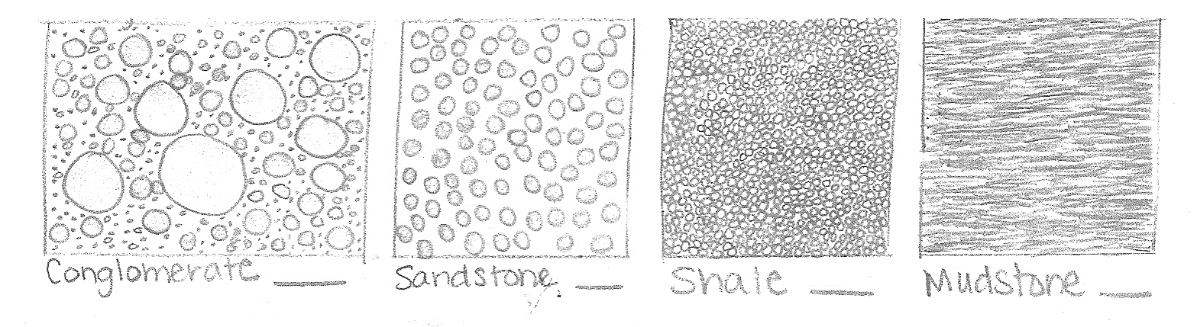
10. Describe each of the four things are necessary for oil to be present:
A. Reservoir Rock-

B. Source Rock-

C. Seal or Cap-

D. Trap-

11.) Describe each of the four types of traps and where the oil might be found. Also color in the area in the diagram where oil might be present.
A. 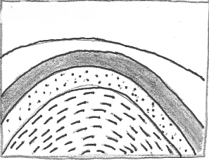 C. 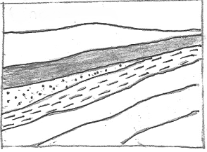

B. 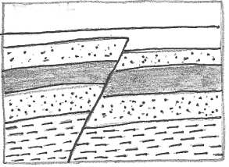 D. 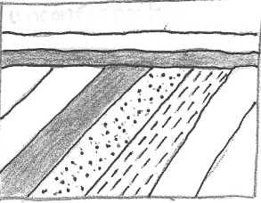
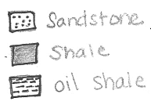
12.) What happens when the cap rock breaks or does not hold the oil underground?

13.) Please pick at least four items that you use that are made from petroleum.

