Shoebox Faulting
Student Handout

Name___________________________________ Date______________________
Normal Fault Record Sheet
Before
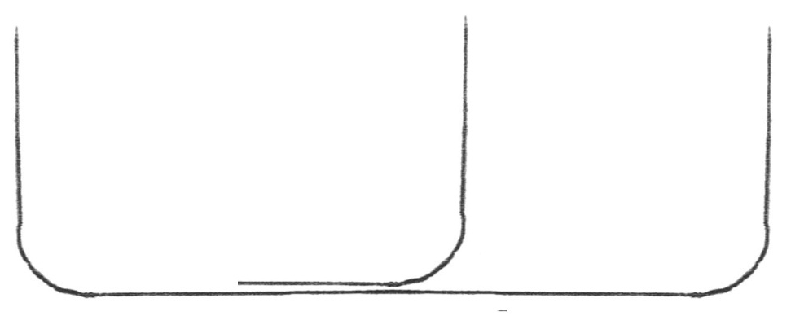

Prediction
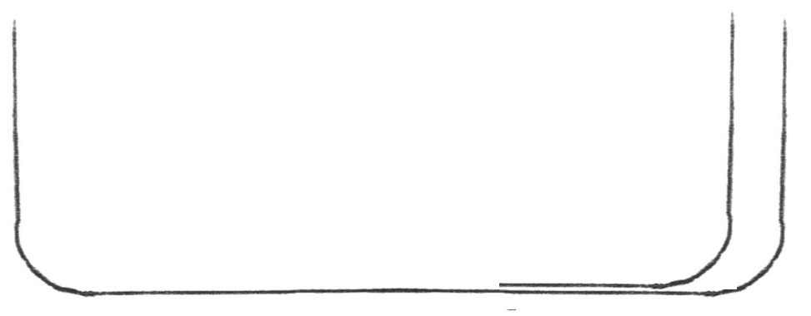

Actual
Label the following: Hang Wall, Foot Wall, Scarp,
Name____________________________________ Period _______ Date ___________

Questions – Normal fault
1. Does the scarp form on the foot wall or hang wall side of the fault? Why?_________
_____________________________________________________________________
2. How can you tell if the fault is normal or reverse?_____________________________
______________________________________________________________________
3. What geologic features would you expect to find in a normal fault zone?__________
_____________________________________________________________________
4. Can you identify any areas near Bakersfield that share characteristics with these geologic features of a fault zone?___________________________________________
______________________________________________________________________
5. Is there any other possible reason for these features that is not related to faulting?__
_____________________________________________________________________

Shoebox Faulting
Student Handout

Name___________________________________ Date______________________
Reverse Fault Record Sheet
Before
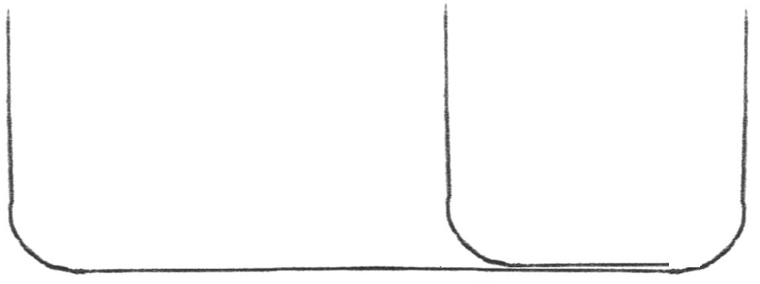

Prediction
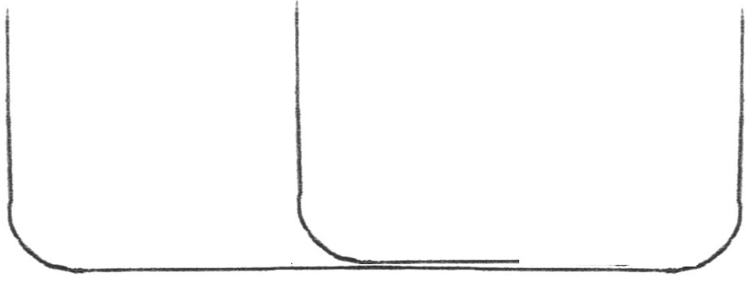

Actual
Label the following: Hang wall, Foot wall
Name___________________________________ Date______________________

Questions – Reverse fault
1. Does the scarp form on the foot wall or hang wall side of the fault? Why?_________
_____________________________________________________________________
2. How can you tell if the fault is normal or reverse?_____________________________
______________________________________________________________________
3. What geologic features would you expect to find in a reverse fault zone?__________
_____________________________________________________________________
4. Can you identify any areas near Bakersfield that share characteristics with these geologic features of a fault zone?___________________________________________
______________________________________________________________________
5. Is there any other possible reason for these features that is not related to faulting?__
_____________________________________________________________________

Shoebox Fault
Instructions

Normal Fault
- Cover Work Area with craft paper or newspaper.
- Place the cut section into the intact shoebox with the cut end 10 cm from the end of the shoebox (See record sheet for placement).
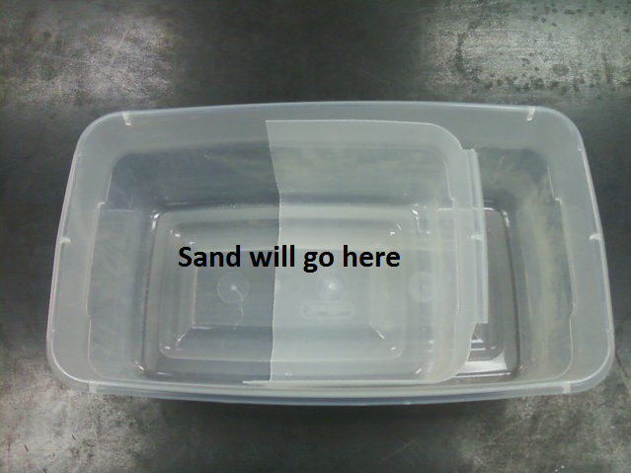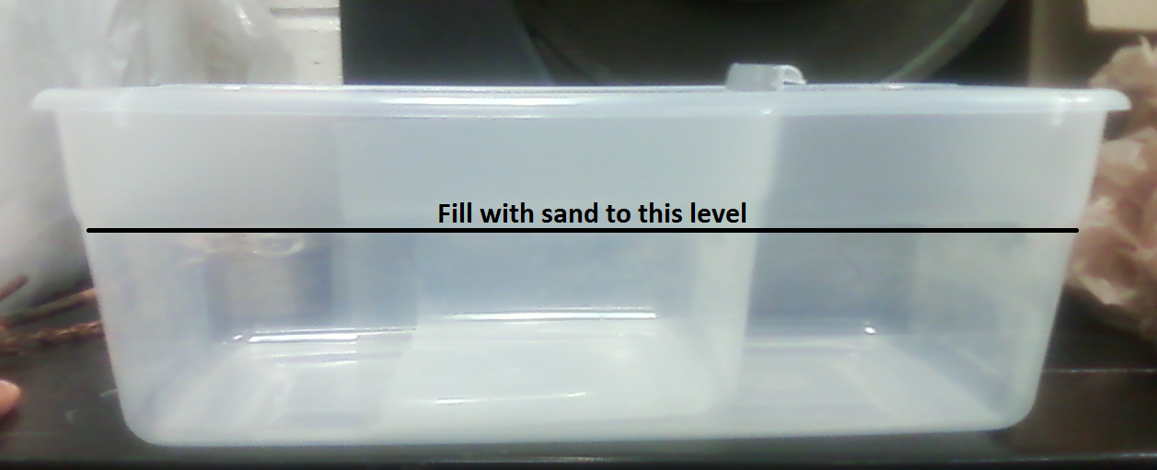

- Put a layer of one type of sand on the bottom of the box covering the cut section. The sand should be at least 1cm thick.
- Add a second layer using different color or textured sand.
- Continue adding layers of sand, alternating colors or textures, until the box is ¾ full. Some layers may be lightly dampened with the water.
- Lay the ruler next to the boxes.
- Make the “Before” drawing of the layers in the box on the record sheet.
- Make a prediction of what will occur when the boxes are pulled apart and make the “Prediction” drawing.
- Have one team member hold one end of the box while another team member gently pulls the” other end. Slide the boxes apart about 15cm.
- Make the “After drawing of the cross section of the box.
- Compare your prediction to your results.

Shoebox Fault
Instructions

Reverse Fault
- Cover Work Area with craft paper or newspaper.
- Place a the cut section into an intact shoebox with the cut end 10 cm from the end of the shoebox (See record sheet for placement).
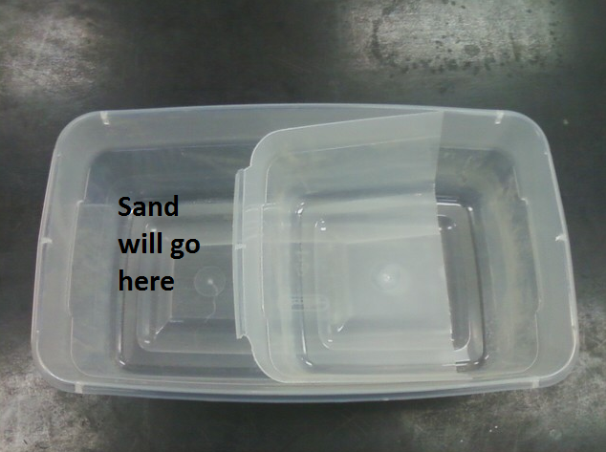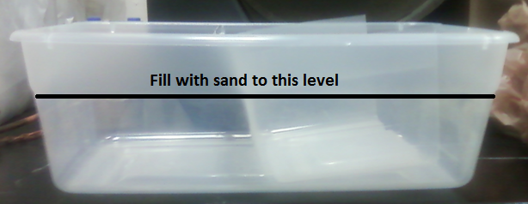
- Put a layer of one type of sand between the end of the cut section and the end of the shoebox at least 1cm thick. Do not put the sand on the cut section.
- Add a second layer using different color or textured sand.
- Continue adding layers of sand, alternating colors or textures, until the box is ½ full. Some layers may be lightly dampened with the water.
- Lay the ruler next to the boxes.
- Make the “Before” drawing of the layers in the box on the record sheet.
- Make a prediction of what will occur when the boxes are pulled apart and make the “Prediction” drawing.
- Have one team member hold one end of the box while another team member gently pushes the other end. Slide the boxes together about 10 - 15cm.
- Make the “After” drawing of the cross section of the box.
- Compare your prediction to your results.

