Shoebox Faulting
Lesson Plan
Objective
Students will know:
Mountain building is the result of plate tectonics.
Faults are created as the result of plate tectonics.
There are several types of faults.

This activity would be an extension to be used after the study of crustal deformation.

6th Grade Standards

Science
Plate Tectonics and Earth’s Structure
1. Plate tectonics accounts for important features of Earth’s surface and major geologic events. As a basis for understanding this concept:
1e. Students know major geologic events, such as earthquakes, volcanic eruptions, and mountain building, result from plate motions.
1f. Students know how to explain major features of California geology (including mountains, faults, volcanoes) in terms of plate tectonics.

Textbook Alignment
Earth Science California Edition, Holt, Rinehart and Winston
Deforming Earth’s Crust: Pgs. 204 – 208

High School Earth Science Standards
Dynamic Earth Processes
3. Plate tectonics operating over geologic time has changed the patterns of land, sea, and mountains on Earth’s surface
3. b. Students know the principal structures that form at the three different kinds of plate boundaries.
3. d. Students know why and how earthquakes occur and the scales used to measure their intensity and magnitude.

Textbook Alignment
Tarbuck, Edward J. and Lutgens, Frederick K. ; illustrated by Dennis Tasa, Earth Science California Edition, Prentice Hall

Materials
For Each Team (2 to 4 students per team):
  - Plastic Shoeboxes (Prepared as explained below)
  - Plastic cups
  - Ruler
  - Craft paper or newspaper
  - Crayons or colored pencils (optional)
  - Record Sheet

For the class:
- Sand, 2 or 3 colors and/or textures, 10 to 12 quarts each.*
- 5 Gallon buckets for each type of sand (Leave one empty for used sand)
- Water (optional)
*Sand may be obtained from home improvement stores or collected from the riverbed, beaches, sandboxes, etc. As a substitute kitty litter may be used however water should be avoided with this material.
Vocabulary

Fault – a fracture in the crust of the Earth
Foot wall - the lower wall of an inclined fault
Hang wall - the upper wall of an inclined fault
Tensile – involving the act of stretching
Compression – the act of pressing or squeezing together
Scarp – A step like feature caused by the action of faulting

Guiding the Activity

1. Schedule
This activity will take 40 to 45 minutes.

2. Background Preparation
Review the background information provided and visit the web sites (see the references below) to view the animations to get an understanding of the mechanisms of faulting.

3. Prepare the Shoeboxes
Each team will need one shoebox that has not been cut and ½ of another shoe box. To prepare the cut shoe box simply cut a full shoe box in half then trim the edge curl from top of the sides, leaving edge curl on the ends. Twelve shoeboxes will make 8 sets of fault simulators. Cut 4 shoeboxes in half to make 8 inserts. Leave the remaining 8 intact.

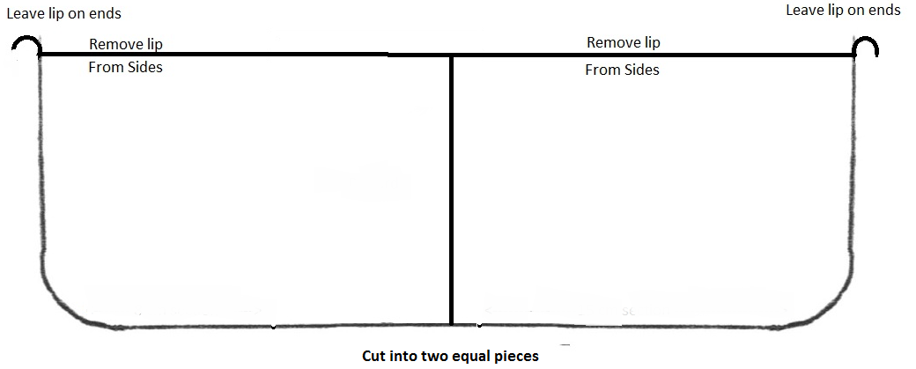

4. Set Up Materials Stations
Place the materials in a location that will be easily accessible by students. Line the areas with craft paper to collect spilled sand. Place the various types of sand into separate containers. Each container should have its own scoop to reduce cross contamination.
Optional: If the sand has been used before it will need to be separated using a screen.

5. Make Content Inquiries
Ask the question “Has anyone ever felt an earthquake?” Discuss the responses focusing on how earthquakes make the earth move. Introduce the idea that earthquakes are like ripples in a pond that radiate out from where a rock is thrown into the water. Explain that earthquakes radiate from a feature called a fault just like the ripples radiate from the rock. Introduce the three fault types.

6. Introduce the Shoebox fault Models
Tell the students that they will be exploring one of the types of faults and how it relates to the geology and geography of Kern County.

7. Explain the Activity
Tell the students they will be working in teams of four. Give the instructions as you demonstrate setting up the boxes.

8. Assign Tasks and Begin the Activity
Getter – get supplies and sand
Holder – hold shoebox so it will not move
Puller/Pusher – pulls or pushes on insert to cause faulting action
Recorder – makes written and visual records of the activity

- Discuss and Compare the Predictions and Observations
Did the sand do as the students expected or was there an unforeseen result? Did both models do the same thing?

- Evaluation
This activity will allow students to visualize the process of faulting and crustal deformation. After performing the activity they should be able to discuss the actions taking place and resulting effect on the landscape.

 | Full Credit | Partial Credit | Half Credit | No Credit
Action and effect – Normal Fault | Student correctly identifies that a normal fault occurs due to expansion of the crust and the falling of the hang wall creates a scarp. They can identify that this is responsible for the creation of the Sierra Nevada Mts. | Student correctly identifies that a normal fault occurs due to expansion of the crust and the falling of the hang wall creates a scarp. | Student correctly identifies that a normal fault occurs due to movement of the crust. | Student cannot identify how a normal fault works.
Action and effect – Reverse Fault | Student correctly identifies that a reverse fault occurs due to compression of the crust and that the hang wall rises above the foot wall. They can identify that this is responsible for folding of rock layers. | Student correctly identifies that a reverse fault occurs due to compression of the crust and that the hang wall rises above the foot wall. | Student correctly identifies that a reverse fault occurs due to compression of the crust. | Student cannot identify how a reverse fault works.

Additional Resources

Fault information (Animations)
http://www.fossweb.com/CA/modules3-6/SolidEarth/activities/geologylab/faultingandfolding/earth-processes/faulting.htm
http://www.iris.edu/gifs/animations/faults.htm
http://www.absorblearning.com/media/attachment.action?quick=13d&att=2823
http://www.absorblearning.com/media/attachment.action?quick=13e&att=2825

Shoebox activity demo/ post activity discussion
http://serc.carleton.edu/files/NAGTWorkshops/structure/activities/Listric-large.mov

Current Earthquake Information
http://earthquake.usgs.gov/earthquakes/recenteqsus/Maps/special/California_Nevada.php
http://earthquake.usgs.gov/earthquakes/recenteqsus
http://earthquake.usgs.gov/earthquakes/recenteqsww

Other Information
http://www.humboldt.edu/~cga/calatlas/atlas.html

Further Reading
Hough, Susan Elizabeth. 2004. Finding Fault in California. Missoula, Montana: Mountain Press.

