Shoebox Faulting
Background Information

Almost everyone who has experienced an earthquake has been awed by the ability of the seemingly solid ground to move. From daily micro-quakes to massive tremors that drastically alter the landscape, California is home to one of the most active and researched fault zones in the world. The San Francisco earthquake of 1906, the 1952 Tehachapi earthquake, the Loma Prieta Earthquake of 1989 and the Northridge earthquake of 1994 are well known major seismic events in the history of California. Few people realize that the earth is constantly moving and changing from hundreds of daily micro-quakes along the various fault systems that crisscross the state.
A fault is a fracture within the earth on which slip or displacement has taken place. Cumulative displacement, or movement, on the fault can be on the scale of centimeters to kilometers. Sudden displacements of centimeters to meters result in earthquakes. Sudden movements less than a centimeter result in small earthquakes that and are associated with the normal creep of the fault.
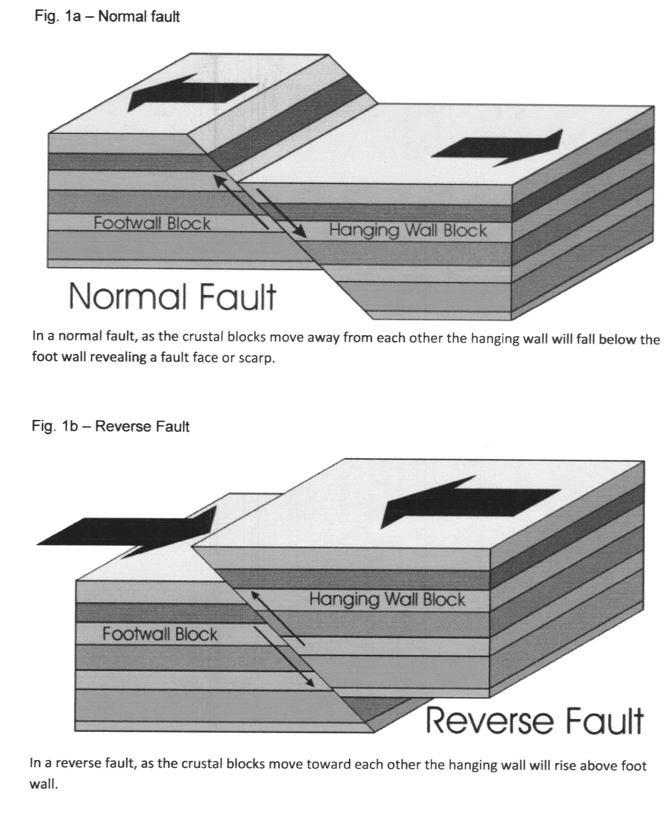
A series of normal faults separate the rocks of the Sierra Nevada Mountains from the San Joaquin Valley. Normal faults are the result of tensile, or stretching, forces that cause crustal extension. In normal faulting as the crustal blocks move away from each other, one side (the hanging-wall block) will drop below the facing side (the footwall block) (Fig 1a). Conversely, reverse faults occur where crustal blocks compress against each other and cause the hanging-wall block to uplift over the footwall block (fig 1b). In Kern County, tectonic processes caused tension in the crustal plates and resulted in the normal faulting along the eastern edge of the San Joaquin Valley. In the southern San Joaquin Valley, Kern Front fault at the Kern River Canyon displays the scarp created when the valley side, a hanging-wall block, fell below the Sierra Nevada side, a footwall block, as the result of normal faulting.
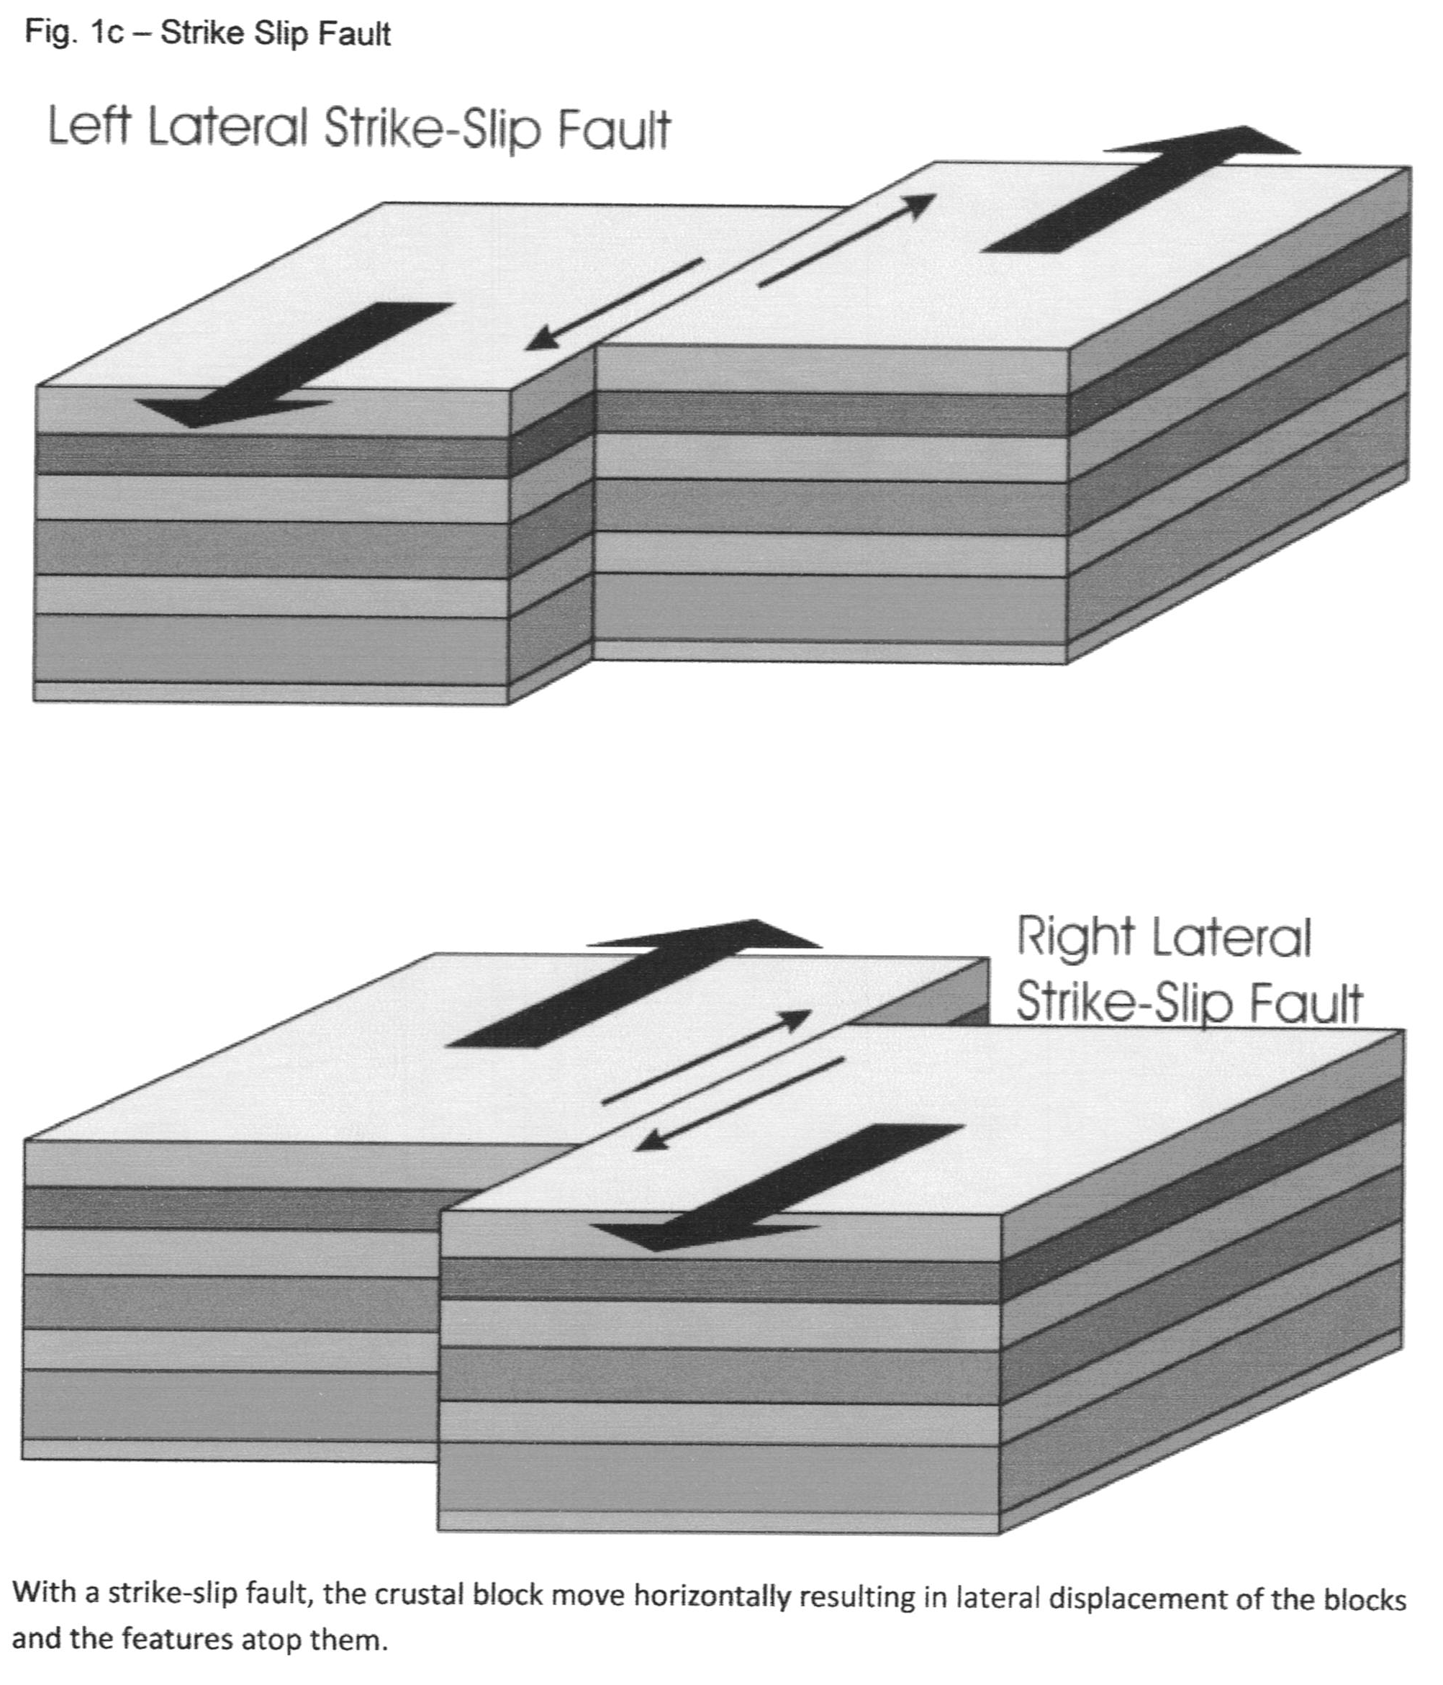
A third fault type is associated with the San Andreas Fault. The San Andreas is a strike-slip fault denoting the boundaries of the Pacific plate and the North American plate. In strike slip faulting, one crustal block is displaced horizontally relative to the adjacent crustal block. The resulting movement causes horizontal displacement of features such as streams and roads (fig 1c). The active zone of the San Andreas near Parkfield, CA moves an average of 3.5 centimeters a year.

Images ©facweb.bhc.edu

