Local Reference
See Map of Giant Sequoia Groves in California by Brown, Hughes, Baisan, Swetnam, and Caprio. Tulare County is north of Kern County. 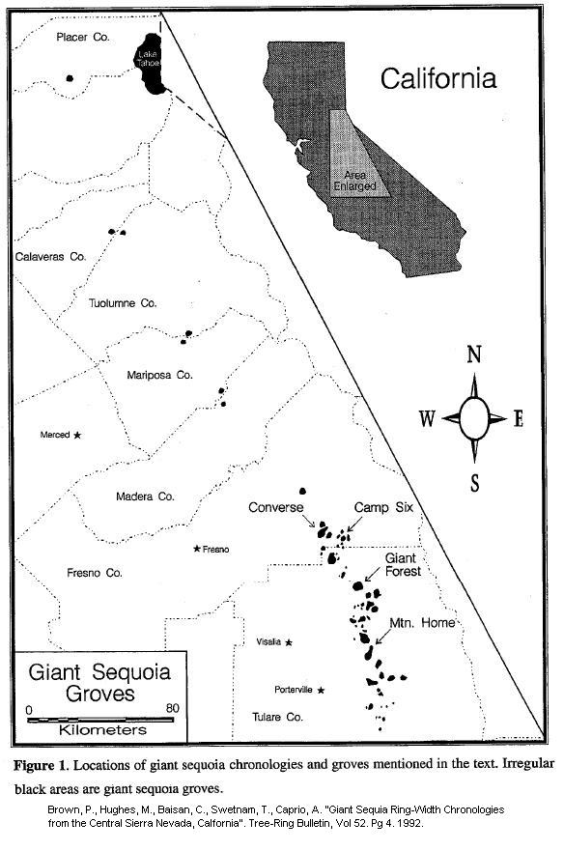

Additional information on paleoclimate from Sequoia National Park
A news article on sequoia tree ring studies that indicate periods of extended drought and fires during the last 3000 years. The article includes photos of a giant tree slab with visible tree rings in addition to photos of giant sequoias, and references to the Medieval Warming Period seen on the graph included in this packet.

http://newswatch.nationalgeographic.com/2010/03/18/sequoias_endured_500_years_fire_and_drought/

