Sharktooth Hill Subduction
Presentation Notes

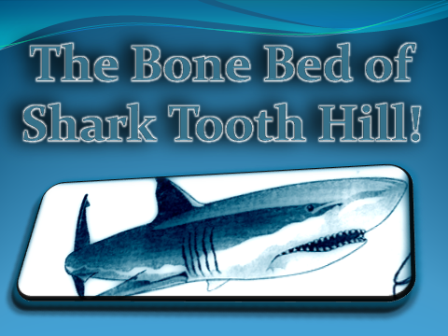
Illustration courtesy of the Buena Vista Museum of Natural History.

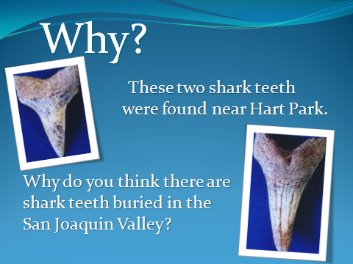
This might be a good place to stop and have students share ideas, think-pair-share, write their own hypotheses, etc. Photos shown are courtesy of the Buena Vista Museum of Natural History.


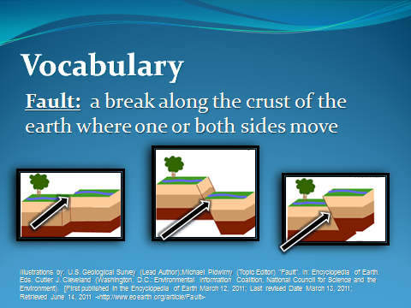



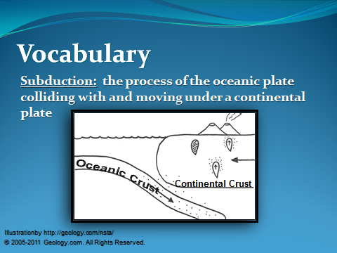

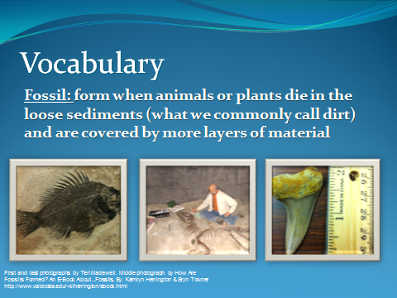



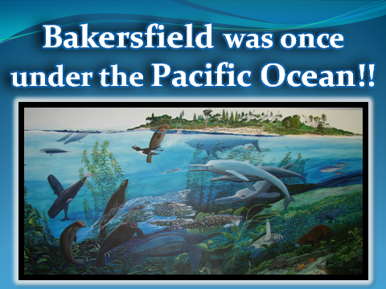
Painting by Ben Nafus of the Buena Vista Museum of Natural History and used here with permission.


Pictures shown are of a Sharktooth Hill fossil quarry courtesy of the Buena Vista Museum of Natural History.

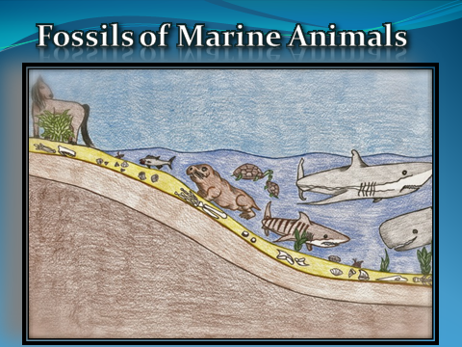
Illustration shows some of the marine and terrestrial life that has been preserved has fossils in the Sharktooth Hill Bone Bed of the Round Mountain Silt. Illustration by Raisa Lora.

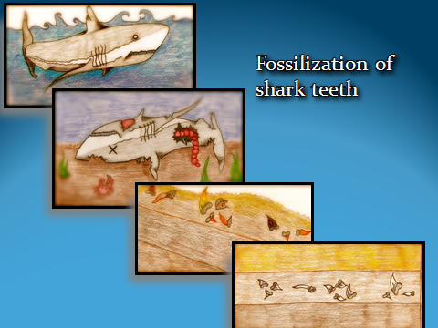
This slide shows how shark teeth may be fossilized. Sharks have cartilaginous skeletons, their only hard body parts are their teeth. Therefore, it is highly unlikely that anything other than their teeth would be preserved in the rock record. Also, sharks lose and replace their teeth multiple times throughout their lives, adding to the number of teeth that could possibly be preserved. Illustrations by Raisa Lora.
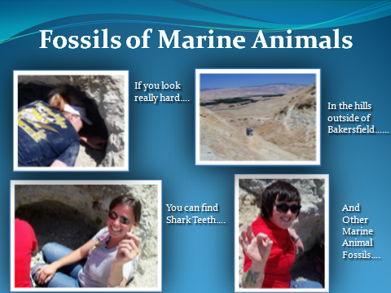

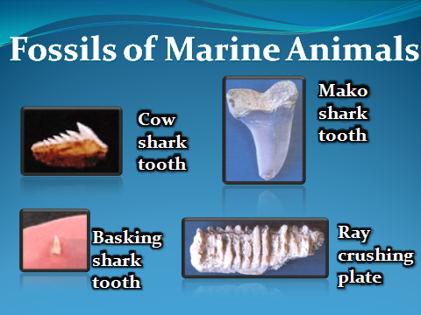
These fossils and more are on display at the Buena Vista Museum of Natural History. Photos are courtesy of the Buena Vista Museum of Natural History.

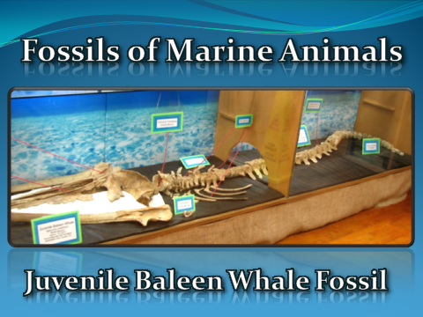
These fossils and more are on display at the Buena Vista Museum of Natural History. Photo courtesy of the Buena Vista Museum of Natural History.



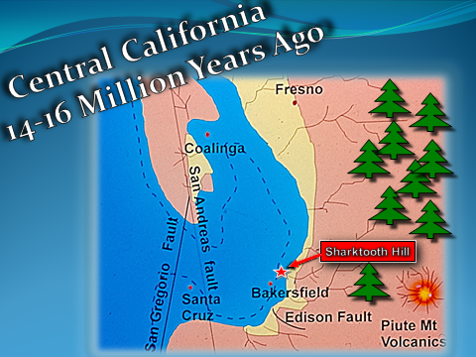
Blue color indicates the Pacific Ocean. The San Andreas Fault (a transform boundary between the Pacific and North American plates) is shown. Notice where Santa Cruz is relative to Bakersfield; movement along the San Andreas has moved Santa Cruz to it’s present location. Also note that at this time the Sierra Nevada mountain range was volcanic at this time, rather than the uplifted granite (intrusive igneous) batholiths of the today. The climate was warmer and wetter than it is today. Diagram courtesy of Buena Vista Museum of Natural History.

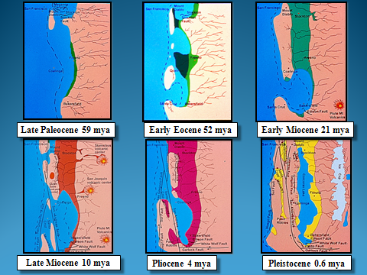
Marine fossils are in Bakersfield because it was once under the Pacific Ocean as shown in these pictures. As the Farallon Plate subducted the Coastal Ranges and Sierra Nevada Mountain range were built up. The valley stayed at a low elevation under water for millions of years. The valley floor began to show as the Sierras eroded and deposited sediment on the valley floor, filling it up. Colors on the map show the ocean (blue), age of sediments (green, red, purple,yellow). mya = million years ago. Diagrams are courtesy of the Buena Vista Museum of Natural History.

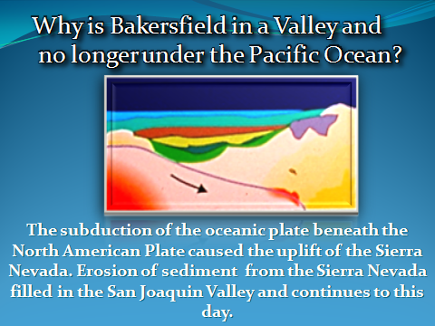

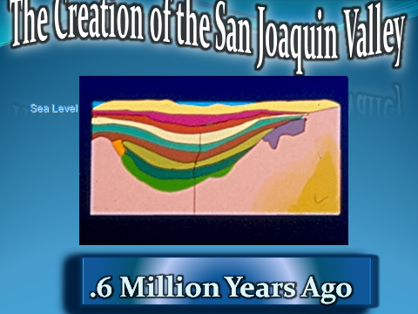

Slide shows a cross section of the southern San Joaquin Valley through time. The blue at the top of every diagram represents ocean water, except for the final diagram where it represents Lake Corcoran. Diagrams courtesy of the Buena Vista Museum of Natural History.

