Teacher Answer Guide
This is a guide for expected answers that students should give. The answers may not be exact but should be very close.

Student Lab Worksheet – Porosity Lab
Pre Lab Questions
- Define Porosity: Porosity is the amount of pore space within a rock.

- Define Permeability: Permeability is how easily the liquid moves through the sediments.

- Describe the difference between a well sorted sediment sample and a poorly sorted sediment sample. A well sorted sample means that all of the grains of sediment are the same size and poorly sorted means that all of the sediment grains are of different sizes.

- Study each of the sediment samples. As a group, predict which type of sediment will have the most available pore space. (Decide which of these “full” cups of sediment will hold the most water.)________________________ Student answers will vary depending on what each group of students believes. Any answer will work as long as they are able to justify it while answering question #5.

- Why did the group agree on the answer for #4? What led your group to believe that the sediment you chose for #4 has the largest amount of pore space?
Students need to give a reason for why they picked their answer for #4.

- Predict which of the sediment samples has the least available pore space._______________________________
Student answers will vary depending on what each group of students believes. Any answer will work as long as they are able to justify it while answering question #7

- Why did the group agree on the answer for #6? What led the group to believe the sediment you chose for #6 has the smallest amount of pore space?
Students need to give a reason for why they picked their answer for #6.
Answer the following questions during the lab as listed in the procedure
FINE GRAIN: 100mL - __________(amount left in the cylinder) = ________________ (total volume of water fine grain holds)
The student’s answer should be between 15-30mL left, giving a volume of anywhere between 70-85mL.
- Why do so many bubbles come out of the sand as the cup fills with water? (think about the permeability of the sand) Because sediment grains are close together, air becomes trapped.

MEDIUM GRAIN: 100mL - __________(amount left in the cylinder) = ________________ (total volume of water medium grain holds)
The student’s answer should be between 15-30mL left, giving a volume of anywhere between 70-85mL.
- Why don’t bubbles come out of the medium grained sediment like they come out of the sand? The channels are larger so air moves through faster. OR The permeability is greater.
LARGE GRAIN: 100mL - __________(amount left in the cylinder) = ________________ (total volume of water large grain holds)
The student’s answer should be between 15-30mL left, giving a volume of anywhere between 70-85mL.
- Now that you have found the volume of pore space in each of the 3 well sorted sediments, please make a prediction about the volume of water that you will be able to pour into the final cup of poorly sorted sediment. Will it be more? Less? The same? Why does the group believe the prediction? Answers will vary. Make sure students justify whatever their prediction may be.
POORLY SORTED: 100mL - __________(amount left in the cylinder) = ________________ (total volume of water poorly sorted holds)
The student’s answer should be between 35-55mL left, giving a volume of anywhere between 45-65mL.
Post Lab Questions
- Which Sediment had the largest amount of pore space? Should be one of the well sorted sediments, sand is most common
- Did any of the sediments hold similar amounts of water to your answer to number one? Which one(s)? Students should list at least two or all three well sorted sediments

- Which sediment sample had the smallest amount of pore space? The poorly sorted sediment
- How much more water did the sediment with the largest amount of pore space hold then the sediment with the least amount of pore space? (subtract #3 from #1)
Answers will vary based on values for #1 and #3
- What made a bigger difference in the amount of water the sediment held, the grain size or sorting? Why does the group believe your choice? Answers will vary but students should be able to identify the sorting of the sediment as the key factor in pore space. All of the well sorted sediments should hold 5-10mL of water more than the poorly sorted sediment.
- Please draw a histogram (bar graph) to show your results from the lab: Be sure to label the vertical axis with volume measurements (each line is 5mL)
Answers will vary. An example has been included. Check to be sure that the student has properly labeled the axis and included all four sediments on the graph.

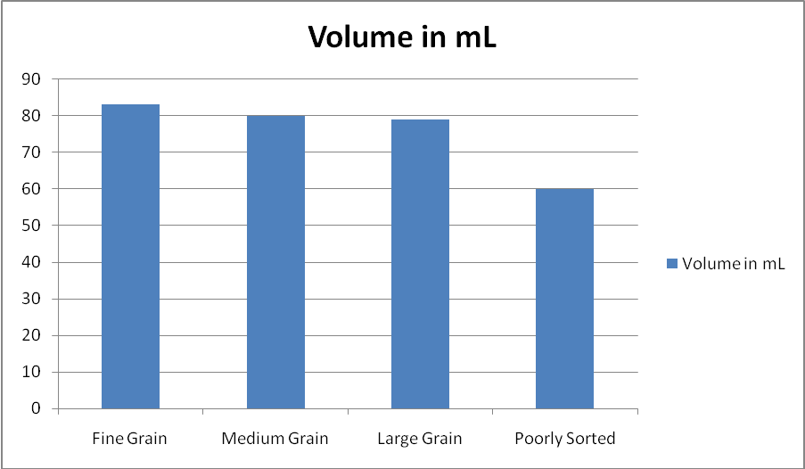

Post Lab Write-up:

The volume of water you were able to pour into each of the sediment cups gives you an idea of the porosity that a rock made with that type of sediment would have. With the information you gained from the lab, what characteristics should a rock have to make a good reservoir for oil? (What makes a rock have lots of pore space?
Student answers will vary, but the paragraph should include information about how well sorted sediment in rocks makes a better reservoir for oil because of higher porosity.

