Kern River Drainage
Background Information

From the tumbling waters of the American River that resulted in the discovery of gold to the fertile ground of the San Joaquin Valley, water has shaped the landscape and driven the California economy. The Kern River supplies fresh water to the southern San Joaquin Valley; and with its tributaries shape the geography of the southern Sierra Nevada Mountains. Students will understand where the Kern River draws its water from, how this natural resource influences the agricultural industry of the valley, and how the Kern River system has affected the geography of the San Joaquin Valley.

This activity will allow students to learn through self-discovery about the economic value of the San Joaquin Valley; specifically, the Kern River’s fresh water contribution to the agriculture industry. Furthermore, it will allow the students to understand how erosion, weathering, and transportation of sediments by the Kern River have shaped the landscape of the mountains and valley. The usage of topographic maps allows the students to gain a hands-on experience with reading a map, calculating the length of the river, and conversion of units all while studying the local geography.

Kern River

The Kern River is the only major south flowing river from the Mt. Whitney area, in the Sierra Nevada Mountains, to the Kern flood plain of the southern San Joaquin Valley.

Currently the Kern River extends 130 km southward from near Mt. Whitney and then turns southwest for another 80 km to its terminus in the southwestern end of the San Joaquin Valley. The Kern River has a drainage area of about 2500 miles² and transports a variable volume with a mean of 8.6 x 10⁸ meters³ / year according to 44 year record.

What is a Topographic Map?
A topographic map is used to represent the 3 dimensional characteristics of a landscape via a 2 dimensional representation. The distinctive characteristic of a topographic map is that the shape of the Earth's surface is shown by contour lines. Contours are imaginary lines that join points of equal elevation on the surface of the land above or below a reference surface, such as mean sea level. Contours make it possible to measure the height of mountains, depths of the ocean bottom, and steepness of slopes. Topographic maps include symbols that represent such features as streets, buildings, streams, and vegetation.

Reading Topographic Maps
Topographic contours are shown in brown by lines of different widths. Each contour is a line of equal elevation; therefore, contours never cross. Contour lines show the general shape of the terrain. To help the user determine elevations, index contours are wider. Elevation values are printed in several places along these lines. The narrower intermediate and supplementary contour lines found between the index contours help to show more details of the land surface shape. Contours lines that are very close together represent steep slopes. Widely spaced contours or an absence of contours means that the ground slope is relatively level. The elevation difference between adjacent contour lines, called the contour interval, is selected to best show the general shape of the terrain. A topographic map of a relatively flat area may have a contour interval of 10 feet or less. Topographic maps in mountainous areas may have contour intervals of 100 feet or more. The contour interval is printed in the margin of each U.S. Geological Survey (USGS) map. (Figure 1)
Interpreting the Colors and Symbols of a Contour Map
Interpreting the colored lines, areas, and other symbols is the first step in using topographic maps. Features are shown as points, lines, or areas, depending on their size and extent. For example, individual houses may be shown as small black squares. For larger buildings, the actual shapes are mapped. In densely built-up areas, most individual buildings are omitted and a tinted area is shown. On some maps, post offices, churches, city halls, and other landmark buildings are shown within the tinted area.
The first features usually noticed on a topographic map are the area features, such as vegetation (green), water (blue), and densely built-up areas (gray or red).
Many features are shown by lines that may be straight, curved, solid, dashed, dotted, or in any combination. The colors of the lines usually indicate similar classes of information: topographic contours (brown); lakes, streams, irrigation ditches, and other hydrographic features (blue); land grids and important roads (red); and other roads and trails, railroads, boundaries, and other cultural features (black). At one time, purple was used as a revision color to show all feature changes.
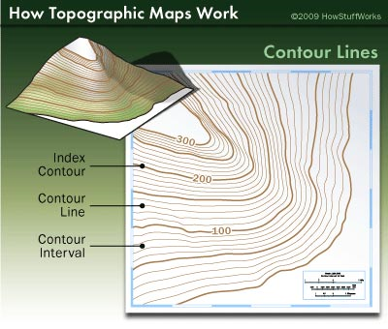
Various point symbols are used to depict features such as buildings, campgrounds, springs, water tanks, mines, survey control points, and wells. Names of places and features are shown in a color corresponding to the type of feature. Many features are identified by labels, such as "Substation" or "Golf Course."

References
http://topomaps.usgs.gov/
http://geomaps.wr.usgs.gov/parks/gmap/

