Why is There Oil in California? Worksheet
Teacher Answer Guide
1.) Describe what California was like tens of millions of years ago.
It did not exist, the edge of the continent was Western Nevada/Shallow ocean.
2.) Define Subduction.
When one plate sinks back into the mantel
3.) Ocean animals turned into the oil we find in Kern County. Some of these included very small animals called diatoms.
4.) What transform boundary was created 10 million years ago?
San Andreas Fault
5.) The shallow sea was closed off from the rest of the ocean 3-4 million years ago.
6.) Oil was formed BEFORE/ AFTER the dinosaurs died? (Circle one)
7.) Define Sedimentary Rock.
Rocks made from sediment, sand, gravel, mud, or organic material
8.) Define Porosity and permiability
Porosity: How much pore space there is in a rock/how much space there is between rock grains. Permeability: the ability for fluids to flow through the pore space in rocks
9. Please rank the porosity of the rock samples from 1 to 4 with 1 being the lowest and 4 being the highest.
3 1 2 4

*Help students with this. Point out that well sorted sediments have a higher porosity. The grains of mud are too small to create much pore space.
10.) What four things are necessary for oil to be present? Describe each.
A.) Reservoir Rock- any porous rock that holds oil or gas
B.) Source Rock- the geologic formation in which oil or gas originates
C.) Seal or Cap- an impermeable layer if rock overlying reservoir.
D.) Trap- a geologic feature that holds oil in one place
11.) Describe each of the five types of traps and where the oil might be found. Also color in the area in the diagram where oil might be present.
A. 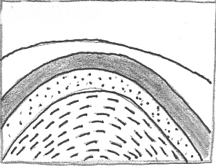
Anticline Trap- layers of strata are bulging up in an inverted bowl and oil is trapped at the top.
B. 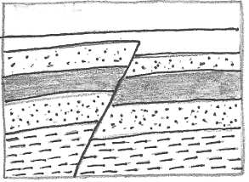
Fault Trap- Faults can cause a permeable formation to line up with an impermeable one to trap oil.
C. 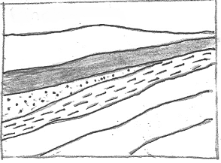
Pinch Out Trap- created when a layer of permeable strata is laid at an angle and the end is blocked by impermeable rock.
D.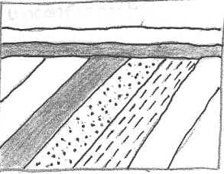
Unconformity Trap- created when he tops of earlier formations are eroded away and an impermeable layer covers the reservoir rock
12.) What happens when the cap rock breaks or does not hold the oil underground?
An oil seep
13.) Please pick at least four items that you use that are made from petroleum.
Answers will vary but must come from the list

