Introduction to Dendrochronology and Crossdating

Counting tree rings can be used to not only to determine the age of a tree, but also to date events such as fires and mark dry years during the life of the tree. Rings form as a tree ages since trees only grow via a thin layer of live cells called the cambium which exist under the bark. “Dark” and “light” rings are formed depending on how dense the layer of growth is, with more dense layers looking darker. When observing an old tree stump one can look closely at the rings and see variation in the spacing between the dark rings and this spacing indicates the amount of growth the tree put on during that time. When the spacing is narrow between dark rings this indicates a relatively dry year during which the tree was stressed and didn't grow much, while wetter years show abundant tree growth.

As the environment around the tree changes, these changes in temperature and precipitation effect tree growth, which show up as changes in the spacing between dark rings. Since trees can live for many years, we can 'read' the patterns of dark rings from the outside of the tree (most recent) towards the inside of the tree (least recent) to look back into the trees life and see how growth has changed from year to year depending on the environment during that growth period. Arrows indicate dark rings that are spaced close together on the drawn tree stump.

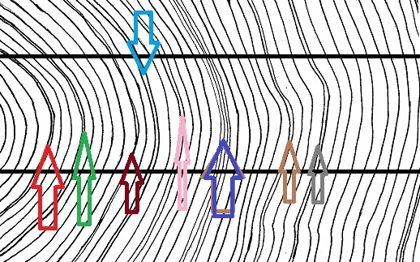

In order to look back beyond the life of one tree, we must find a nearby tree, alive or dead, which was alive during the time of our initial tree sample. Since both trees were alive during an overlapping period, they both would experience similar weather, so during a dry year both trees would show narrow dark rings since both would be stressed that year. After several years of experiencing the same weather, both trees will have recorded similar patterns of growth on their rings as the years are either wet or dry. By comparing dark tree rings from both trees, we can overlap the matching patterns:

Introduction to Dendrochronology and Crossdating

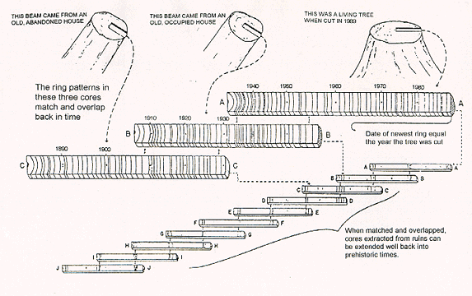

This technique, known as crossdating, allows samples of tree rings from different trees to overlap with each other and merge into a continuous record of dry and wet years in an area. When this goes back far enough in time, we can look at the tree ring record and find changes in climate for that area, with some time periods experiencing above average rainfall and others drought. By comparing with other tree ring records across the world, climatologists can find shifts in climate experienced around the world.

This activity will teach students about the importance of studying tree rings and help them understand how scientists learn that climate has changed during the past. By the end of the exercise the students will know how to properly identify and count growth rings, plus learn the basics of identifying patterns of dry years and crossdating them with other trees to extend a tree record and note climate events that occurred over a hundred years ago.

