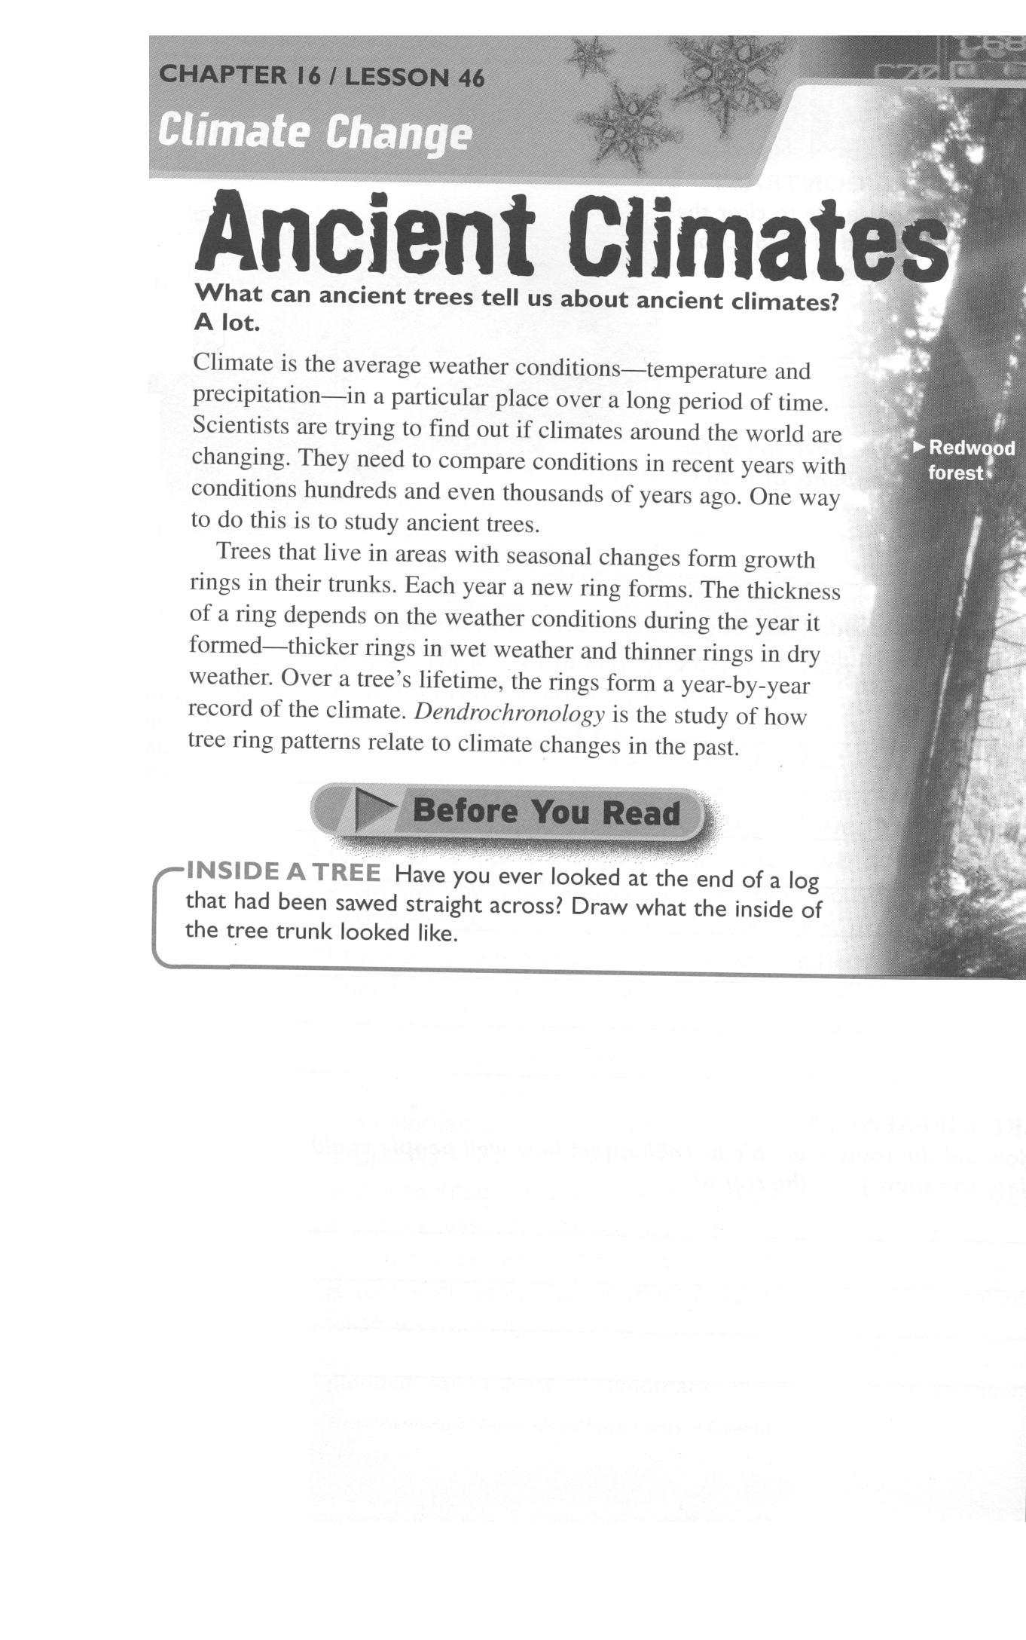
Great Source Education Group (In Collaboration with NSTA), Earth Science Daybook, United States, 2002.Climate Change, Ancient Climates Chapter 16, p 166.

