HW-9.1: Trap Integrity

Introduction:
In this homework, you will explore capillary sealing and stress sealing of buoyant fluids (oil, gas, C02) as discussed in Chapter 9 of (Flemings, 2021). In a previous homework, you calculated the hydrocarbon phase and water phase pressures in the J2 sand of the Bullwinkle oil field. You found the following results:
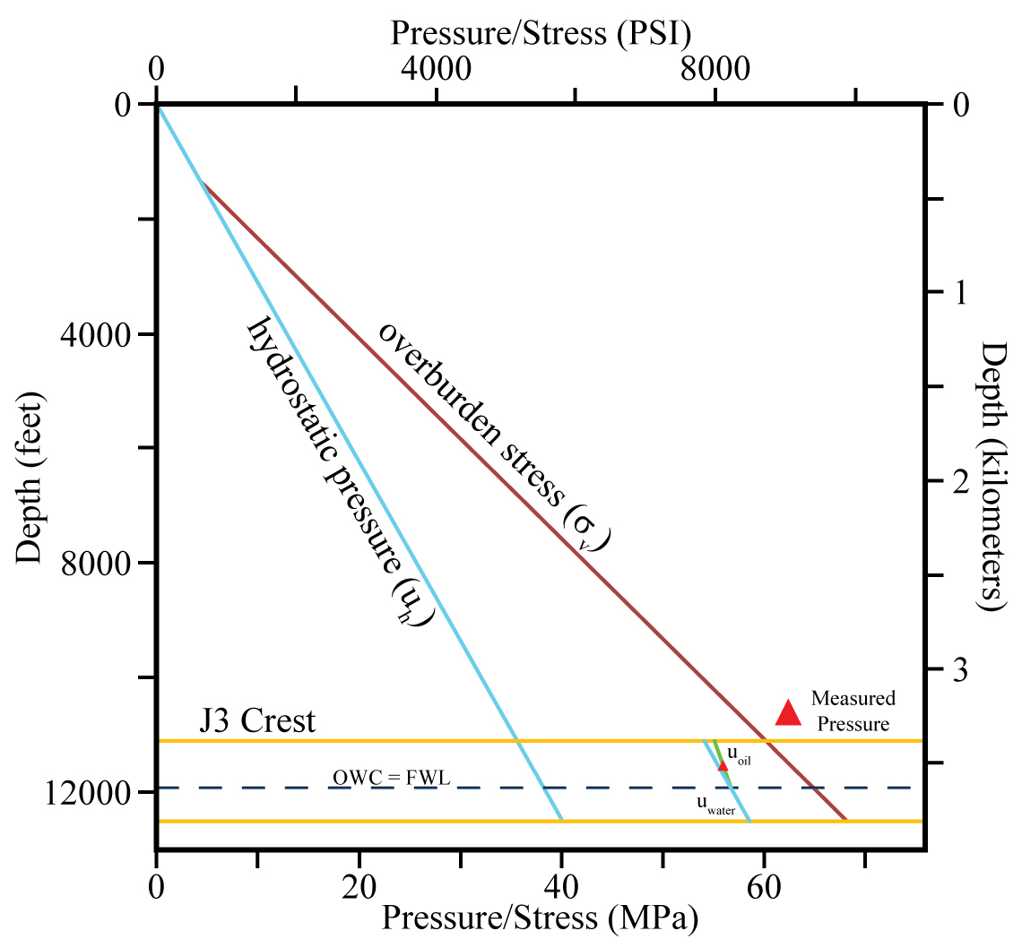
Figure A1: Pressure profiles at Bullwinkle from sea level through the J3 sand.
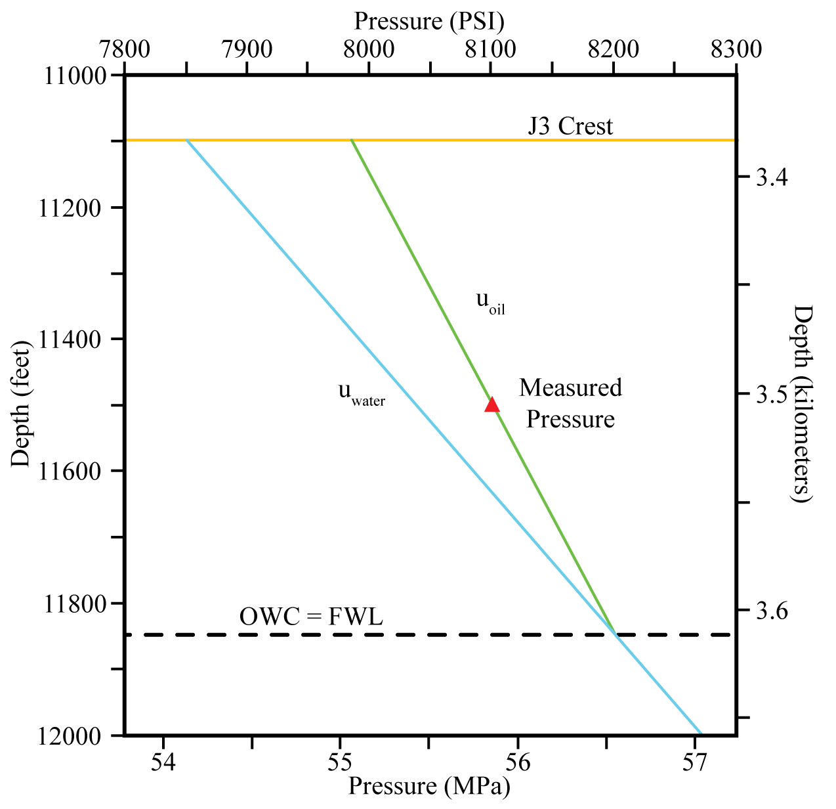
Figure A2: OWC is at 11850 ft, and the FWL is at 11850 ft. At the OWC, $u_{cmig}$ = 0 within the reservoir, which means that the depth of the OWC and the FWL are the same.

Table 1
At the top of the J3 Sand
Pressures | PSI | MPa
Oil (u_{o}) | 7986 | 55.06
Water (u_{w}) | 7851 | 54.13
Capillary (u_{o} - u_{aquifer}) | 134 | 0.92
Aquifer Overpressure (u_{aquifer} - u_{h}) | 2689 | 18.55
Overburden Stress (σ_{v}) | 8720 | 60.12

Table 2
Zero Displacement Pressure Scenario
Capillary Pressure @ OWC (psi) |  |  |  | PSI | MPa
 |  |  |  | 0 | 0
Depth @ FWL (psi) |  |  |  | feet | meters
 |  |  |  | 11850 | 3612
Note: Pressure @ OWC = Pressure at FWL
 |  |  |  |  |  | PSI | MPa
Pressures @ top of the J3 Sand |  |  |  | Oil |  | 7986 | 55.06
 |  |  |  | Water |  | 7851 | 54.13
 |  |  |  | Capillary (u_{cow}) |  | 134 | 0.92

Capillary Sealing:

Task:
The mercury-air capillary behavior of the caprock is shown in Figure 3. $u_{de}$ is the extrapolated displacement pressure and this is interpreted to be the migration pressure ($u_{cmig})$ (See Chapter 2, text).
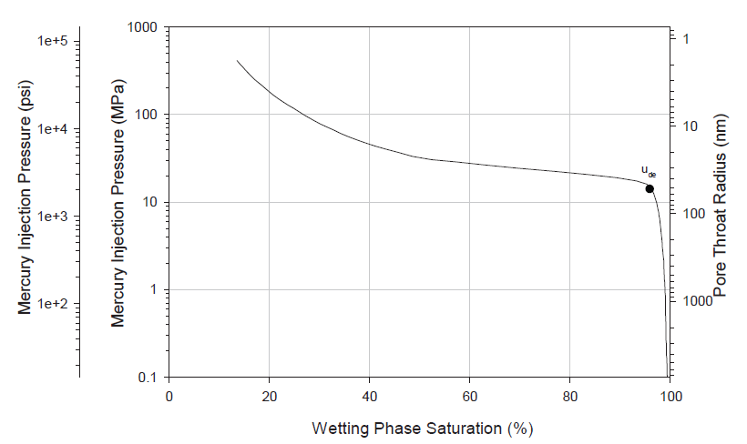
Figure 3: See (Flemings, 2021) Figure 9.4.

To convert mercury-air injection pressure to oil water, use Eq. 2.22.

$u_{cow} =u_{cHg-air} \left(\frac{γ_{ow}\cos{θ_{ow}}}{γ_{Hg-air}\cos{θ_{Hg-air}}}\right)$. Eq. 2.22

Parameters for Eq. 2.22 are shown in Table 3:

Table 3 (see Table 2.4 in text).
System | Contact Angle $(θ)$ | Interfacial Tension $\left(γ\right)(\frac{dyn}{cm})$
Laboratory
Air-water | 0 | 72
Oil-water | 30 | 48
Air-Mercury | 140 | 480
Air-oil | 0 | 24
Reservoir
Water-oil | 30 | 30
Water-gas | 0 | 50*
Oil-gas | 0 | 24
*pressure/temp dep.

The height above the free water level is:

$h_{FWL}=\frac{u_{cmig}}{∆ρg}.$ Eq. 9.1

Assume that water gradient is 0.46 psi/ft (1.06 g/cc) and that the oil gradient is 0.29 psi/ft (0.67 g/cc). Use contact angle (θ) = 0° for oil/water reservoir conditions.

Calculate the maximum column of oil that can be trapped (Eq. 9.1).

$$u_{cow}=u_{cHgair} \left(\frac{γ_{ow}\cos{θ_{ow}}}{γ_{Hgair}\cos{θ_{Hgair}}}\right)$$

$u_{cow} =3000 psi \left(\frac{30*\cos{(0)}}{480*cos{(140)}}\right)=245 PSI (1.69 MPa)$,
where 3000 psi is interpreted to be the migration pressure, which is found at a wetting phase saturation of about 95%.

$$u_{cow} =3000 psi \left(\frac{30*1}{480*(-0.765)}\right)=245 PSI (1.69 MPa)$$

$$h=\frac{u_{cow}}{∆ρgh}=\frac{245 PSI}{0.46\frac{psi}{ft}-0.29\frac{psi}{ft}}=1440 feet of oil (439 meters)$$

See Figure 9.5 and associated discussion for further insight.

Mechanical Seal: Hydraulic Fracture control:
Leak off measurements at Bullwinkle constrain the value of the least principal stress in the seal ${(σ}_{3}^{seal})$ to be $8546 PSI.$
$u_{crit}^{res}=σ_{3}^{seal}$, Eq. 9.3
$h_{FWL}=\frac{u_{crit}^{res}-u_{w}^{res}}{Δρg}$. Eq. 9.4
Assume that the caprock pore pressure is equal to the water phase pressure at the top of the sand. What is the height of the trapped column (eq. 9.3)?

$$h_{FWL}=\frac{σ_{3}^{seal}-u_{w}^{res}}{∆ρg}=\frac{8546psi-7851psi}{0.46\frac{psi}{ft}-0.29\frac{psi}{ft}}=4088 feet of oil (1246 meters)$$

See Figure 9.14 and associated discussion for further insight.

Mechanical Seal: Critically stressed fault:

Calculate the hydrocarbon column height if there is leakage along critically stressed faults (Eq. 9.5).

Calculate $u_{crit}^{res}$:

$u_{crit}^{res}=\frac{σ_{h}^{seal}-\left(\frac{1-sinϕ^{'}}{1+sinϕ^{'}}\right)σ_{v}}{\left[1-\left(\frac{1-sinϕ^{'}}{1+sinϕ^{'}}\right)\right]}$. Eq. 9.5
Assume the friction angle ($ϕ^{'})$ is equal to 30 degrees and that the caprock pore pressure is equal to the water phase pressure at the top of the sand. What is the height of the trapped column (Eqs. 9.3 & 9.5)?

$$u_{crit}^{res}= \frac{σ_{h}^{seal}-\left(\frac{1-sinϕ}{1+sinϕ}\right)σ_{v}}{\left[1-\left(\frac{1-sinϕ}{1+sinϕ}\right)\right]}$$

$$u_{crit}= \frac{8546-\left(\frac{1-sin30}{1+sin30}\right)8720}{\left[1-\left(\frac{1-sin30}{1+sin30}\right)\right]}=8459 PSI (58.32 MPa)$$

$$u_{crit}= \frac{8546-\left(\frac{1-0.5}{1+0.5}\right)8720}{\left[1-\left(\frac{1-0.5}{1+0.5}\right)\right]}=8459 PSI (58.32 MPa)$$

$$u_{crit}= \frac{8546-\left(\frac{1}{3}\right)8720}{\left[1-\left(\frac{1}{3}\right)\right]}=8459 PSI (58.32 MPa)$$

$$h=\frac{u_{crit}-u_{w}}{∆ρg}=\frac{8459psi-7851psi}{0.46\frac{psi}{ft}-0.29\frac{psi}{ft}}=3576 feet of oil (1090 meters)$$

See Figure 9.14 and associated discussion for further insight

Flemings, P., 2021, A Concise Guide to Geopressure: Origin, Prediction, and Applications, Cambridge Press.

