HW-6: Pore Pressure Prediction given unloading (velocity to effective stress)

ANSWERS

We will use the Bowers Approach (after Bowers (1995)):

$σ_{v}^{'}=σ_{v}-u$ Eq. 1
$u=σ_{v}-σ_{v}'$ Eq. 2

For the virgin consolidation curve, the Bowers relation is as follows:

$v=5000+A{σ'}^{B}$ Eq. 3a
$σ'={\left(\frac{v-5000}{A}\right)}^{\frac{1}{B}}$ Eq. 3b
$u= σ_{v}-{\left(\frac{v-5000}{A}\right)}^{\frac{1}{B}}$ Eq. 3c

Fig. 1: Velocity vs. hydrostatic effective stress to a depth of 6500’ in the Pathfinder well. Parameters A and B (Eq. 3a) are found to be: that A=4.475 and B = 0.852

In your previous exercise you predicted the pressure profile shown below:

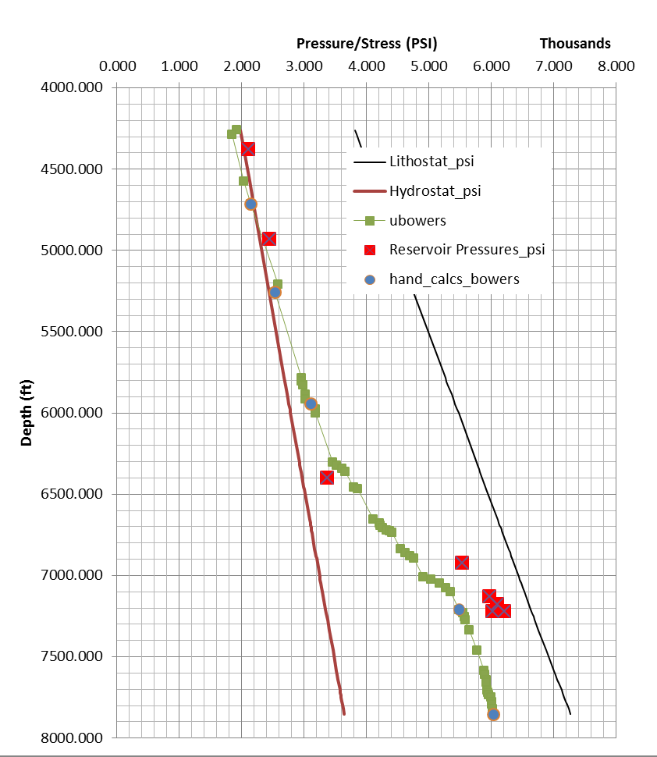
Fig. 2: Pressure prediction from Bowers technique with no unloading.

You also calculated the following result based on Equations 1-3:

Label | Depth (ft) | Vel (ft/s) | n | Uh (psi) | Sv (psi) | u (psi) | σ_{v}'
a | 4717 | 8102 | .243 | 2189 | 4239 | 2080 | 2159
b | 5258 | 8289 | .235 | 2440 | 4754 | 2442 | 2312
c | 5945 | 8439 | .229 | 2757 | 5423 | 2986 | 2437
d | 7210 | 6668 | .307 | 3345 | 6638 | 5595 | 1043
e | 7854 | 6788 | .302 | 3644 | 7273 | 6142 | 1131
Table 1

- To consider the process of unloading, plot porosity (n) vs. effective stress from Table 1 label each point (a, b, c.. etc). Imagine that you are a sediment package being buried along the pressure-depth profile shown in Figure 2. What is the evolution of your effective stress?

a
b
c
d
e
Fig. 3: Plot porosity vs. effective stress for Table 1. Label points a through e.
- Next, plot velocity vs. effective stress for Table 1:

Fig. 4: Plot velocity vs. effective stress for Table 1. Label points a through e.

Bowers (1995) has proposed that if unloading has occurred, the velocity-effective stress relationship is as follows:
$v=5000+A{\left(σ_{max}'{\left(\frac{σ}{σ_{max}'}\right)}^{\left(\frac{1}{U}\right)}\right)}^{B}$ Eq. 4
Where A and B are as previously defined (e.g. Fig. 1). U is a third parameter and:
$σ_{max}'={\left(\frac{v_{max}-5000}{A}\right)}^{\frac{1}{B}}$ Eq. 5

V_{max} is usually set to equal the velocity at the depth where the velocity reversal takes place. This assumes that all formations within the reversal at one time passed through the same maximum stress state. This may not be generally true. However, Bowers (1995) states that it has been found to work satisfactorily. The maximum velocity is approximately 8439ft/sec at 6000 ft of depth (Fig. 5). Based on Eq. 5 and given V_{max} = 8439 ft/sec, σ_{max} = 2300 psi (Fig. 6) (we assume A=4.475 and B = 0.852 for Eq. 5, fig. 1).

Equation 4 can be re-arranged:
$σ^{'}=σ_{max⁡}^{'}{\left[\frac{1}{{σ'}_{max}}{\left(\frac{v-5000}{A}\right)}^{\frac{1}{B}}\right]}^{U}$ Eq. 6

Therefore, in the unloaded zone, pressure can be solved for as:
$u=σ-σ_{max⁡}^{'}{\left[\frac{1}{{σ'}_{max}}{\left(\frac{v-5000}{A}\right)}^{\frac{1}{B}}\right]}^{U}$ Eq. 7

Equation 6 and 7 are solved in a simple spread sheet application that you are provided.

Fig. 5: The maximum velocity is approximately 8439ft/sec at 6000 ft of depth.

Fig. 6: The maximum effective stress is approximately 2300 psi at a depth of 6000 feet.

A | 4.475
B | .852
U | 2 (variable, but 3 is suggested by Bowers for GOM)
V_{max} | 8439 ft/sec
σ_{max}’ (Eq. 5) | 2434 psi
Table 2: Table of input parameters.

- Calculate the value of the pore pressure and fill in the table below and then plot these values in Figure 2. A spread sheet is provided for the below calculations. Please plot these values in Figures 3 and 4. Please think about how the rock is buried. Next, plot the loading history of the material predicted by this model. Points above 6000 feet should lie on the original compression line and points below 6000 feet should lie on the unloaded line.

label | Depth (ft) | Vel (ft/s) | n | Uh (psi) | Sv (psi) | u | sv' | u unload | sv' unload
a | 4717 | 8102 | 0.243 | 2189 | 4239 | 2143 | 2096 | 2323 | 1916
b | 5258 | 8289 | 0.235 | 2440 | 4754 | 2536 | 2218 | 2556 | 2198
c | 5945 | 8439 | 0.229 | 2757 | 5423 | 3107 | 2316 | 2982 | 2441
d | 7210 | 6668 | 0.307 | 3345 | 6638 | 5489 | 1149 | 6191 | 447
e | 7854 | 6788 | 0.302 | 3644 | 7273 | 6044 | 1229 | 6747 | 526
Table 3: Answer set

- Finally, on the excel spread sheet vary the parameters U and V max to get a sense of the unloading behavior. Try as you look at the plots to think about the stress history of any particular package of sediment.

Fig.7: Answer

Illustration of unloading curve predicted (red) vs. virgin consolidation relationship (blue).

