HW-5.3: Pore Pressure Prediction — Pathfinder
(accounting for illite-smectite transition)
ANSWERS
We will use the approach of Lahaan (2002). This approach assumes that the compression behavior of an illitic mixture is different from that of a smectitic mixture:
$σ_{v}^{'}=σ_{v}-u$ Eq. 1
$u=σ_{v}-σ_{v}'$ Eq. 2
$n=n_{m}+n_{o}e^{-βσ_{v}'}$ Eq. 3
$u=σ_{v}-\frac{1}{β}\ln\left(\frac{n_{o}}{n-n_{m}}\right)$ Eq. 4
Lahann (2002) suggests that the Pathfinder well (EI-330) has undergone a transformation from smectite-rich to illite-rich sediments with depth due to diagenesis (Fig. 1).
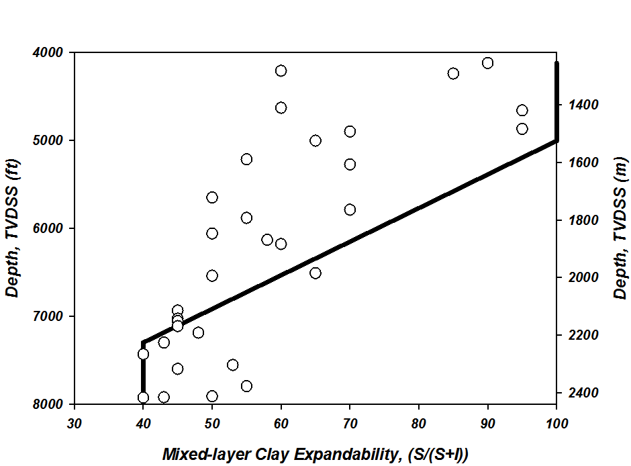
Figure 1: Depth variation of mixed-layer clay expandability, smectite/(smectite + illite) (S/(S+I)) for the Pathfinder well. Data from Table 1 of Losh et al. (1999). Note that below 1500 m, the maximum smectite fraction is 0.7, substantially less than the maximum value above 1500 m. A top of the clay transition of 1500m is interpreted for this well (from Lahann 2002).
Lahaan (2002) suggests this transition can be accounted for with Eq. 3 describing the compression behavior: n_{m}=0.12 for smectitic material and n_{m}= 0.03 for illitic material. A regression of Eq. 3 assuming the material is smectitic (n_{m}=0.12) is shown in Fig. 1 (solid line). The illite compression curve (n_{m}=0.03) is shown below this (dotted line).
$$Smectite: n=0.12+0.27e^{-3.67e-4}$$
$$Illite: n=0.03+0.27e^{-3.67e-4}$$
Figure 2: Illustration of how to perform regression to solve for n₀ and β. Note that these are not the same parameters as derived in the Hubbert regression.
- Calculate the value of the pore pressure (Eq. 4) and fill in the table below and then plot these values in Figure 3.
label | Depth (ft) | n | u_{h} (psi) | σv (psi) | u smectite | u  illite | u  mid
a | 4717 | 0.243 | 2189 | 4239 | 2217 | 3621 | 2937
b | 5258 | 0.235 | 2440 | 4754 | 2560 | 4038 | 3323
c | 5945 | 0.229 | 2757 | 5423 | 3092 | 4631 | 3891
d | 7210 | 0.307 | 3345 | 6638 | 5687 | 6692 | 6183
e | 7854 | 0.302 | 3644 | 7273 | 6253 | 7281 | 6761

References:
Lahann, Richard, 2002, Impact of Smectite Diagenesis on Compaction Modeling and Compaction Equilibrium, in: A.R. Huffman and G.L. Bowers, eds., Pressure Regimes in Sedimentary Basins and Their Prediction: AAPG Memoir 76, p. 61-72.
Gutierrez, Mario A., Braunsdorf, Neil R., Couzens, Brent, A., 2006, Calibration and ranking of pore-pressure prediction models, The Leading Edge, v.23, p. 52-59
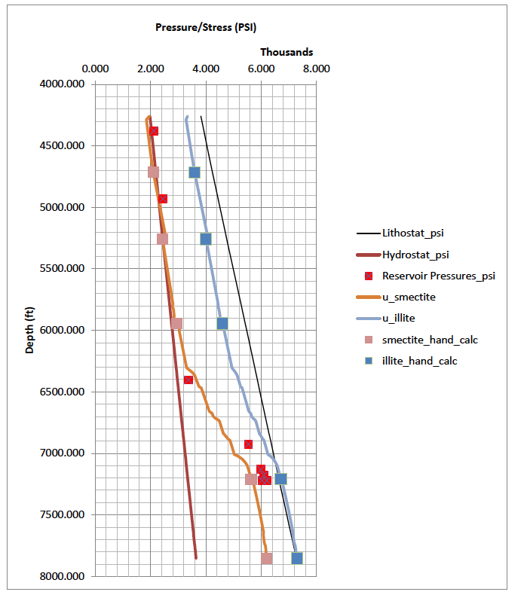
Figure 3:

