HW-5.1: Pore Pressure Prediction—Eugene Island 330—Answer Sheet

Goal:
This homework supplements the discussion of pore pressure prediction discussed in Chapter 5 (Flemings, 2021). We will predict pressure in the E.I.-330 A20ST well. See Chapter 5, Figures 5.4-5.6, and 5.13, (Flemings, 2021)). We will use the normal compaction trend parameters that you derived in HW5.1. We will both calculate by hand and use the spreadsheet ‘NCT_Spread_sheet_and_PPP_EI-330’ to predict the pressure.

Hubbert Approach
Goal: Use Hubbert’s approach to predict pore pressure in the E.I.-330 A20ST well. See Chapter 5, Figures 5.4-5.6.

Approach:
$σ_{v}^{'}=σ_{v}-u$ Eq. 1
$u=σ_{v}-σ_{v}'$ Eq. 2
$n=n_{0}e^{-βσ_{v}'}$ Eq. 3
$u=σ_{v}-\frac{1}{β}\ln\left(\frac{n_{o}}{n}\right)$ Eq. 4
Based on the normal compaction trend shown in Figure 1 (i.e. $β=2.15 x{10}^{-4} and n_{o}=0.38)$, calculate the pore pressure (u) and fill in Table 1 and then plot these values in Figure 2. Double your value of β and re-calculate the pore pressure and place in the right column of Table 1.

Depth (ft) | n | U_{h} (PSI) | σ_{v} (PSI) | u (Eq. 4) (PSI)  β=2.54 x 10⁻⁴  PSI⁻¹ | u (Eq. 4) (PSI)  β=5.1 x 10⁻⁴ PSI⁻¹
4714 | 0.24 | 2091 | 4123 | 1937 | 3030
6657 | 0.25 | 2951 | 5987 | 3991 | 4989
7231 | 0.31 | 3206 | 6543 | 5547 | 6045
7854 | 0.30 | 3482 | 7157 | 6009 | 6583
Table 2. Exercise for estimating pore pressure at EI-330.

Example Calculation:
$$u\left(4714 feet\right)=4123- \left(\frac{1}{{2.15*10}^{-4}}\right)\ln\left(\frac{0.384}{0.24}\right)=1937psi$$

Figure 1: Compression curve from NCT Exercise. This analysis shows . $β=2.15 x{10}^{-4} and n_{o}=0.38$ (Eq. 3)

Figure 2: The hand-calculated points are shown and the prediction from the spreadsheet ‘NCT_Spread_sheet_and_PPP_EI-330’ is overlain

Bowers
Calculate the value of the pore pressure and fill in the table below and then plot these values in Figure 2.
Depth (ft) | Vel (ft/s) | Uh (psi) | Sv (psi) | u (psi) | σ_{v}'
4717 | 8102 | 2189 | 4239 | 2080 | 2159
5258 | 8289 | 2440 | 4754 | 2442 | 2312
5945 | 8439 | 2757 | 5423 | 2986 | 2437
7210 | 6668 | 3345 | 6638 | 5595 | 1043
7854 | 6788 | 3644 | 7273 | 6142 | 1131
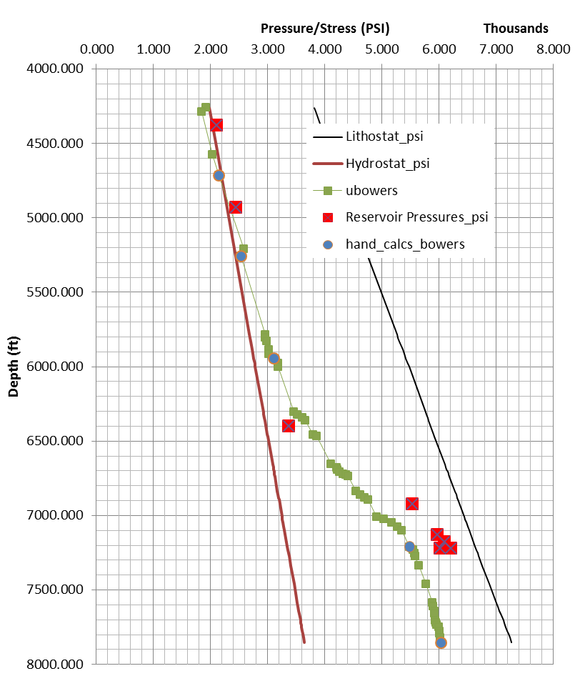
Fig. 3. The hand-calculated points are shown and the prediction from the spreadsheet ‘NCT_Spread_sheet_and_PPP_EI-330’ is overlain

