HW-5.1: Determining Normal Compaction Trend (NCT)
ANSWERS
This homework supplements the discussion over the derivation of normal compaction parameters discussed in Chapter 5 (Flemings, 2021). We will use various approaches to determine the normal compaction trend (NCT). We will use the Eugene Island 33#1 well to determine the NCT (Fig 1). This well has the most complete suite of shallow log data that is close to the 330 A20 well where we wish to predict pressure. In this well, pressures are approximately hydrostatic to 5,000 feet. We will use the spreadsheet ‘NCT_Spread_sheet_and_PPP_EI-330’ to interpret the normal compaction trend parameters for the 331 #1 data.
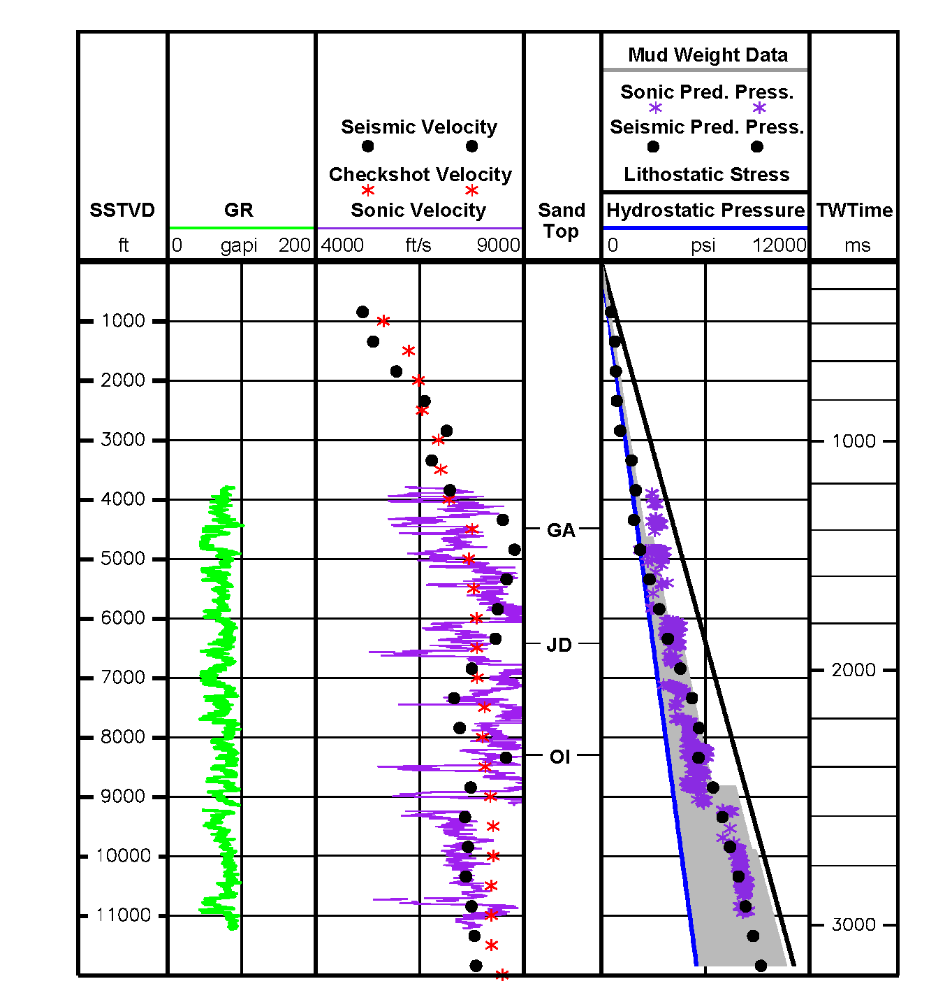
Fig. 1: 331B10 well. This is along the same path as the 331#1. Pore pressures are approximately hydrostatic to at least 4000 feet and perhaps 6,000 feet.

Fig. 2: Mudstone picks from the Eugene Island 331 #1 well. This exploration well had the most complete log of the shallow section and is thus used to determine compression parameters.

Hubbert Approach:
To determine the parameters n_{o} and $β$, we first calculate the porosity from the sonic log.
$n={1- \left(\frac{dt_{ma}}{dt}\right)}^{\frac{1}{f}}$ Eq. 1
$dt_{ma}=220\frac{μsec}{m}$ Eq. 2
$f=2.19$ Eq. 3

Hubbert’s compression relationship is as follows:
$σ_{v}^{'}=σ_{v}-u$ Eq. 4
$u=σ_{v}-σ_{v}'$ Eq. 5
$n=n_{0}e^{-βσ_{v}'}$ Eq. 6
$u=σ_{v}-\frac{1}{β}\ln\left(\frac{n_{o}}{n}\right)$ Eq. 7

To calculate n_{o} and $β$, we perform an exponential regression on a plot of hydrostatic effective stress vs. n_dt (Figure 3)

Fig 3. Plot of hydrostatic effective stress (σ_{vh}’) vs. porosity (n) calculated from sonic log (Eq. 1). Exponential regression paramaters are shown (Eq. 6). See Figure 5.11 {Flemings, 2021 #4105}.

Table 2: interpreted Hubbert parameters.
Depth (ft.) interval of regression | Excel Row Interval | n₀ | β (PSI⁻¹)
0-3000 | 3-31 | 0.39 | 2.24e-4
0-5300 | 3-38 | 0.39 | 1.24e-4
1200-4300’ | 12-34 | 0.38 | 2.13e-4

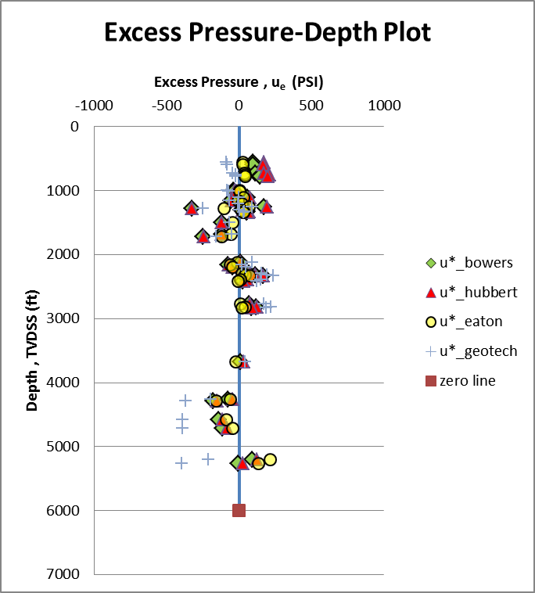
Figure 4: Example result plotting the degree of overpressure from the normal compaction trend. Because the regression was down over an interval interpreted to be hydrostatic, the result should show hydrostatic pressures (see Figure 5.11 and 5.12 (Flemings, 2021))

Bowers Approach:
Bowers assumed that effective stress was a power law function of velocity (Eq. 2)
$σ_{v}^{'}=σ_{v}-u$ Eq. 8
$σ_{v}'= {\left(\frac{v-5000}{A}\right)}^{\frac{1}{B}}$ Eq. 9
$u=σ_{v}-σ_{v}'$ Eq. 10
$u= σ_{v}-{\left(\frac{v-5000}{A}\right)}^{\frac{1}{B}}$ Eq. 11
To constrain the parameters A and B, we plot the hydrostatic effective stress against v -5000 (Fig 4)

Fig 5: Example plot of hydrostatic effective stress ($σ_{vh}'$) against velocity less 5,000 feet (v-5000). See Figure 5.11 {Flemings, 2021 #4105}.
- Calculate A and B parameters using the provided spread sheet. Examine the predicted pressure vs. depth and come up with your preferred model.
Table 1: interpreted Bowers parameters.
Depth (ft.) interval of regression | Excel Row Interval | A | B
0-3000 | 3-31 | .27 | 1.28
0-5300 | 3-38 | .616 | 1.14
1200-4300’ | 12-34 | 4.6 | .845

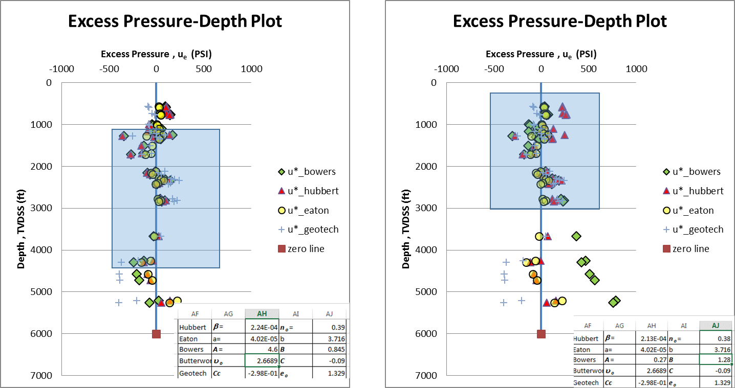Fig. 6: Example result for two different regression ranges. Note that the Bowers Equation produces very different results for two different regression ranges. Our goal is to produce hydrostatic pressures (no overpressure) throughout this section. See Figure 5.12 {Flemings, 2021 #4105}.

Flemings, P. (2021). A Concise Guide to Geopressure: Origin, Prediction, and Applications: Cambridge Press.

