HW-4: Sedimentation
In the Ursa Basin, the sedimentation rate over the last 50,000 yrs is 12mm/yr (0.012m/yr). The coefficient of consolidation (c_{v}) for mudstone is 2x10⁻⁸ m²/s (0.63 m²/yr). In contrast the coefficient of consolidation for siltstone is 2x10⁻⁷ m²/s (6.3 m²/yr).
The coefficient of consolidation is:
$c_{v}=\frac{k}{μm_{v}}$, Eq. 1
Where k is permeability, μ is viscosity, and m_{v} is compressibility.
The Time Factor, T is:
$T=\frac{m^{2}t}{c_{v}}$ Eq. 2
- How severe is the overpressure for these two lithologies at a depth of 200 meters and 500 meters? Please plot predicted pressure on Figure 2. Please estimate the predicted pressure and $λ^{*}$ value ($λ^{*}=\frac{u^{*}}{σ_{v}-u_{h}})$ at 200 and 500 meters after 50,000 years.

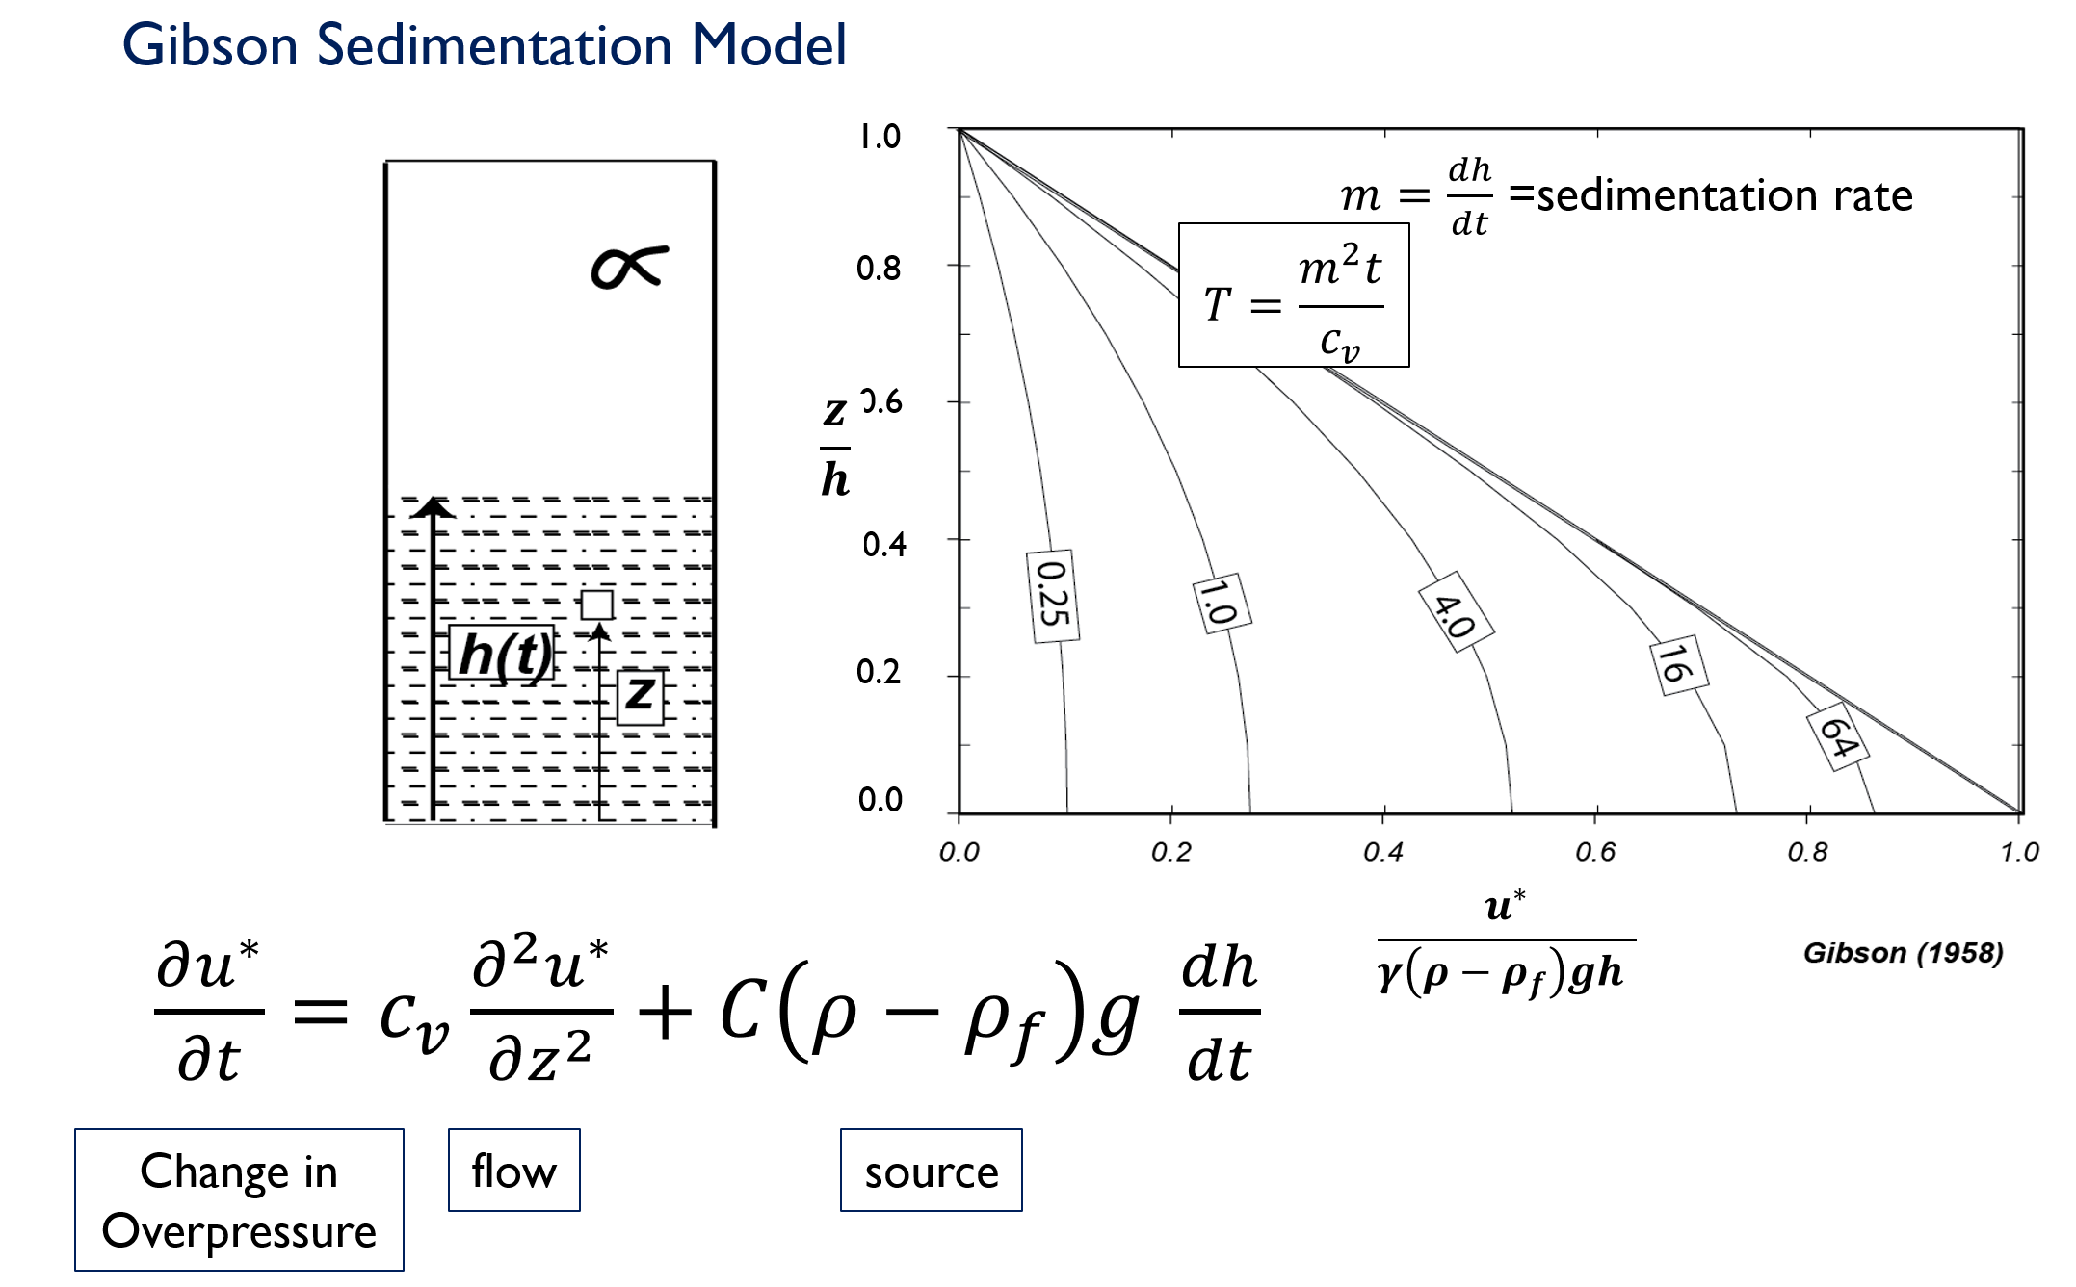
Figure 1: Right: A plot of Gibson’s Time Factor (#s in boxes). Relative Pressure (hydrostatic to lithostatic) is on the horizontal axis. Relative depth is on the vertical axis.

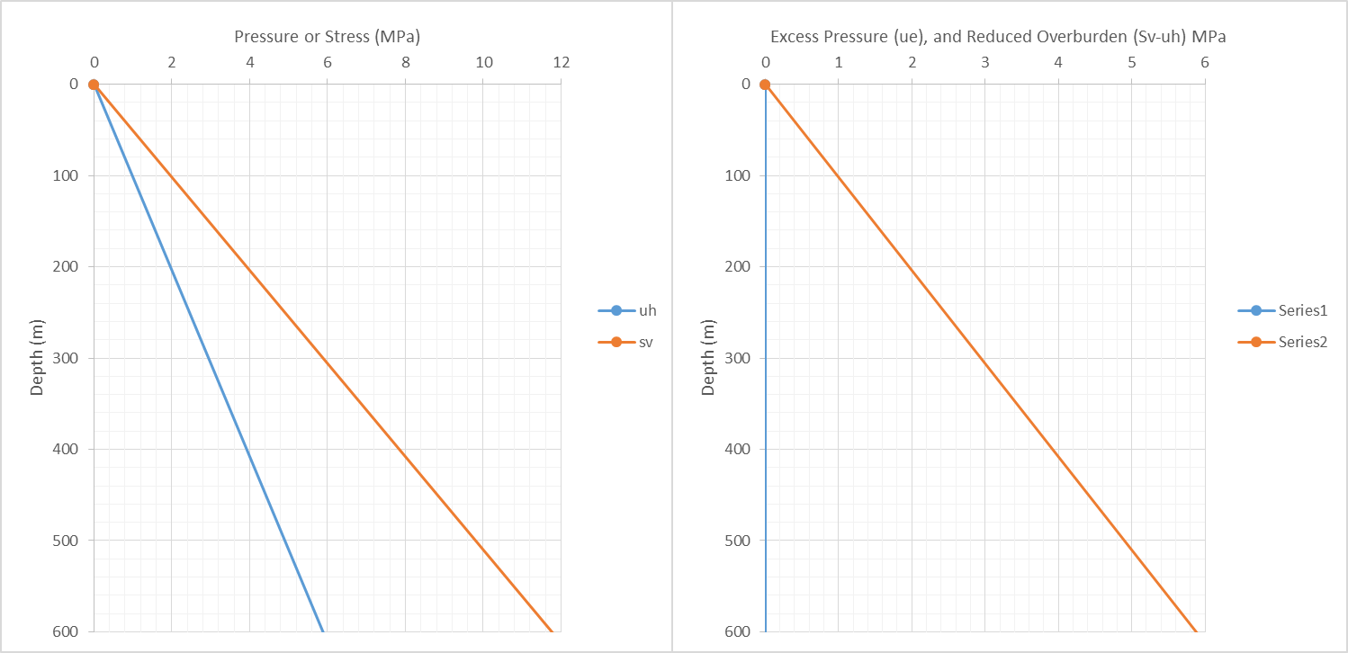
Figure 2: Pressure vs. depth (left) and Overpressure vs. Depth (right). Please plot pressure for both the mudstone and siltstone.
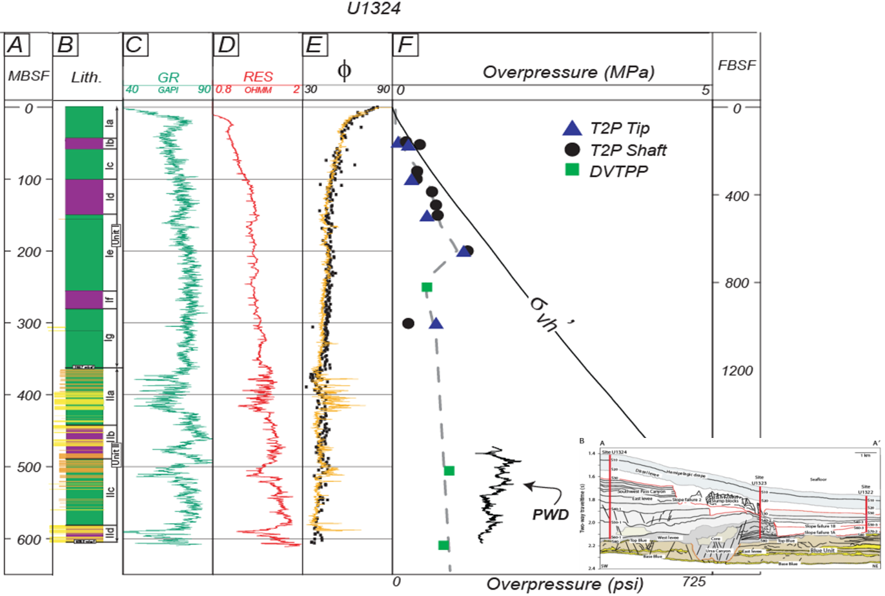
Figure 3: Observed pressures in the Ursa Basin.

- c_{v} at Eugene Island at the depths you are looking at is very similar, but the permeability is much lower. Can you propose a reason why?

- A way to estimate the time scale of pressure dissipation is to look at the scaling of the coefficient of consolidation.
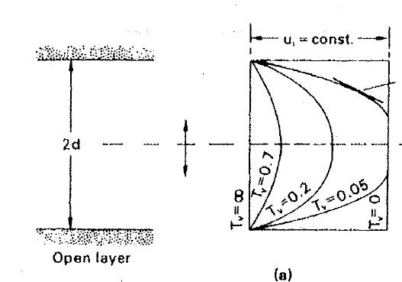

$C_{v}=\frac{k}{u m_{v}}$ Eq. 3
$T_{v}=\frac{C_{v}t}{d^{2}}$ Eq. 4
Please rearrange Eq. 4 to solve for ‘t’ given T_{v} = 0.7 to estimate the time it will take to dissipate the majority of the pressure at 0.01m, 100m, and 1000m thickness of Ursa mudstone.

