HW-3c: Friction Lab
Background:
Consider a block at rest on a level surface. Imagine trying to pull the box across the surface. The force opposing the pulling force F is the frictional force (f).
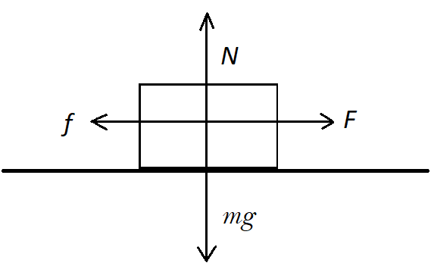
N is the normal force of the plane acting on the block, which equals the weight of the block mg, where m is the mass of the block and g is the acceleration due to gravity. $f$ is the resisting force to sliding and F is the applied driving force. At the moment of sliding, the resisting force equals the driving force ($f=F).$
Amonton’s first law is that the force of friction (f) is directly proportional to the applied load, or:
$f∝N$ Eq. 1
or
$f=μN$ Eq. 2
where $μ$ is the friction coefficient.
Amonton’s second law is that the force of friction is independent of area of contact. At some levels this is self-evident. If we divide equation 2 by the area of contact (A), then
$\frac{f}{A}=\frac{μN}{A}$, Eq. 3
or
$τ=μσ_{n}$, Eq. 4
where $τ$ is the shear stress and $σ_{n}$ is the normal stress.

The constant µ is the coefficient of friction. There are two coefficients of friction to consider in this interaction. The first is the coefficient of static friction µ_{s}. This applies up to the point when the block breaks free and just begins to move. The second is the coefficient of kinetic friction µ_{k}. This applies when the block is sliding along the surface with constant speed (i.e. with no acceleration).

When the surface is an inclined plane, the normal force N changes. It is still perpendicular to the plane but the weight of the block is not. The contribution of the weight to N depends on the angle of inclination $ϕ$.
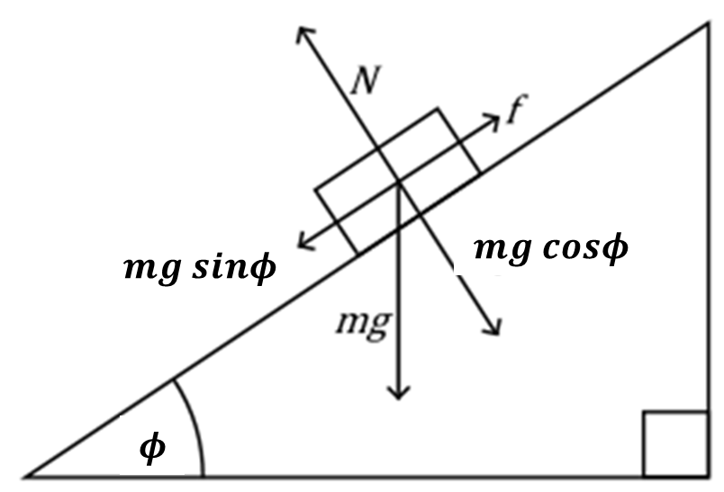
From the diagram, at the point of failure, the frictional force $(f)$ is:
$f=mgsinϕ,$ Eq. 5
and the normal force (N) is:
$N=mgcosϕ$. Eq. 6
Equation 2 can be restated as,
$mgsinϕ=μmgcosϕ,$ Eq. 7
Or
$μ=\frac{sinϕ}{cosϕ}=tanϕ$ Eq.8
The friction coefficient is the slope at which the block begins to slide. So, if we measure the angle of inclination $(ϕ)$ when the block first breaks free we get µ_{s} directly. Likewise, if we measure $(ϕ)$ as the block slides with constant speed down the incline we get µ_{k}.
The goal of this lab is to test whether Amonton’s 1st law is correct. To do so, we will determine the friction coefficient for one material at a range of normal stresses.

Procedure:
Materials:
- Hinged wood surface with acrylic and aluminum covers
- Aluminum plate
- Slotted weights
- Spring scale
- Scissor jack
- Support blocks for scissor jack
- Ruler

Place the plate on the right end of the plane (opposite the hinge). Hold the ruler upright at the 50 cm mark on the base and slowly lift the plane to increase the angle. Stop when the plate just breaks free and begins to move.
Measure the height h of the plane; the length l of the base is 50 cm. Calculate the coefficient of static friction.
With this procedure, we measured the following:
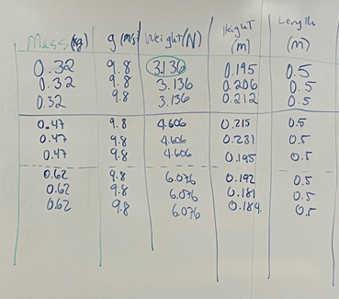

- From these data, calculate the average coefficient of friction and the average friction angle for the experiments with the three different weights. Construct a table. Describe how this supports, or does not support, Amonton’s first law.

- Construct a Mohr diagram illustrating the stress state for each of the three experiments. To construct this diagram, I found it helpful to remember the following. First, a Mohr diagram is in stress, not pressure. I assumed a unit area (A). Thus, I really just plotted the forces, but I envisioned that they were divided by an area equal to unity. Second, I drew out the geometric relationships so that I could calculate the center point of the Mohr Circle (the average stress) and the radius of the Mohr’s circle. These are illustrated in my pencil sketch below.
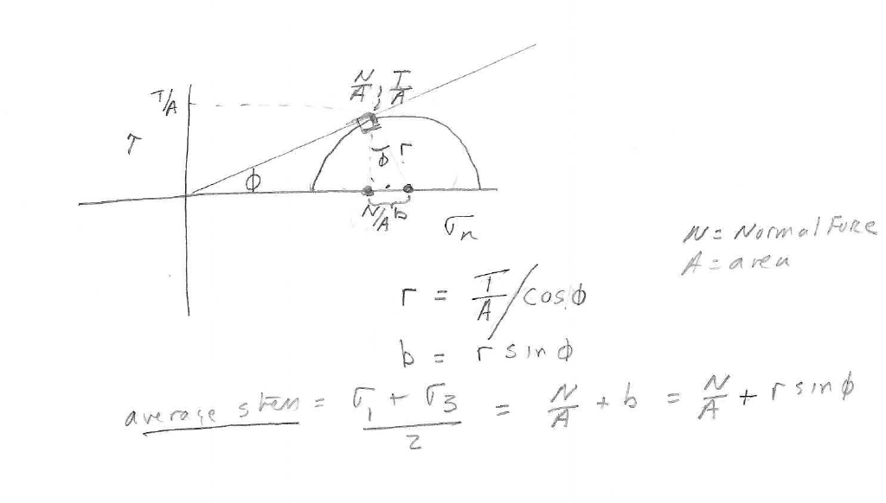
  - Please construct a table that shows the average stress and the maximum shear stress for each stress state. On your diagram, label the stress points where failure occurs. Make sure you plot your inferred failure surface. Make sure you plot the Mohr circle for each experiment on the diagram.

- Imagine that you are in a normal faulting situation. What is the dip angle at which a fault will form. Imagine you are in a compressional (thrust fault) setting. What is the dip angle at which faults will form?

- Please construct an ‘average stress’ vs. ‘maximum shear stress’ plot for each of the three stress points. Please label the failure line such that the failure line intersects with the average stress points.

