HW-3b: Stress State, Mohr Diagrams, and Coulomb Failure

ANSWERS

Consider the following compression experiment. The maximum principal stress ${(σ}_{1})$ is increased while the least principal stress ${(σ}_{3})$ is held constant.



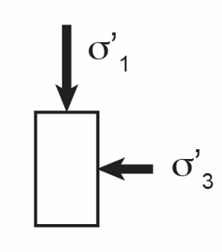

Figure 1: Sketch of experiment. The maximum principal stress is increased while the least principal stress is held constant.

1. Plot this evolving stress state on a Mohr Diagram (Figure 2 top). Label the maximum shear stress. What is the angle of the plane to the maximum principal stress that carries the maximum shear stress?

See attached figure. The maximum shear stress is at the top of the Mohr’s circle. This is at an angle $2θ=90° or θ=45°$

1. Plot this evolving stress state on an average stress (s) vs. maximum shear stress plot (t) (Figure 2 bottom).

See attached figure.

1. The rock fails when $σ_{1}$ reaches 21 MPa.
   1. Plot the Coulomb failure surface on Figure 2, top. Calculate the friction angle $\left(ϕ\right).$ Calculate the angle of this failure surface relative to the orientation of $σ_{1}$.

I am sure there is an analytical way to do this. However, I just did it by plotting the Mohr Circle and drawing a tangent to that. The slope of that tangent is ~30 degrees. In section b, below, I show how to calculate that directly.

The relationship between the friction angle ( $ϕ)$ and the angle of the surface relative to $σ_{1}$ ( $θ_{cr})$ is:

$$θ_{cr}=45+\frac{ϕ^{'}}{2}$$

We find

* 1. On Figure 2, bottom. Draw a line from the origin to Pt. B. Calculate the slope of this line and determine the friction angle.

$$\frac{t}{s}=sinϕ$$

If you take the value of $\frac{t}{s}$ at Pt. B and solve for the friction angle ( $ϕ),$ we find $ϕ=30°.$

