HW-3b: Stress State, Mohr Diagrams, and Coulomb Failure

PT | $σ_{1}$(MPa) | $σ_{3}$ (MPa) | $$\frac{σ_{1}+σ_{3}}{2}$$ | $$\frac{σ_{1}-σ_{3}}{2}$$
A | 13 | 7
 | 15 | 7
 | 17 | 7
 | 19 | 7
B | 21 | 7

Consider the following compression experiment. The maximum principal stress ${(σ}_{1})$ is increased while the least principal stress ${(σ}_{3})$ is held constant.
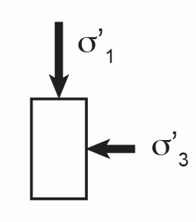
Figure 1: Sketch of experiment. The maximum principal stress is increased while the least principal stress is held constant.

- Plot this evolving stress state on a Mohr Diagram (Figure 2 top). Label the maximum shear stress. What is the angle of the plane to the maximum principal stress that carries the maximum shear stress?

- Plot this evolving stress state on an average stress (s) vs. maximum shear stress plot (t) (Figure 2 bottom).

- The rock fails when $σ_{1}$ reaches 21 MPa.
  - Plot the Coulomb failure surface on Figure 2, top. Calculate the friction angle $\left(ϕ\right).$Calculate the angle of this failure surface relative to the orientation of $σ_{1}$.
  - On Figure 2, bottom. Draw a line from the origin to Pt. B. Calculate the slope of this line and determine the friction angle.
$$\frac{t}{s}=sinϕ$$
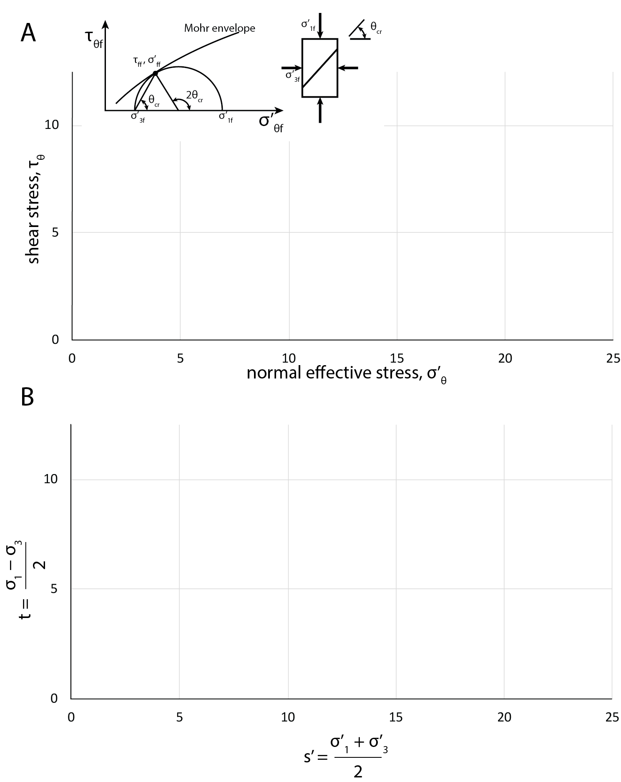
Figure 2: Mohr Diagram.

