HW-3a: Compression Behavior in the Lower Shikoku of the Nankai Fold and Thrust Belt

ANSWERS

We will study the compression behavior in the Nankai Trough at IODP Site 1173. Figures 1 and 2 provide a general overview of this location.

- See the spreadsheet associated with this homework. For Site 1173, please calculate the overburden from the seafloor downwards. Note that the data start at 350 meters below seafloor. I have provided the total vertical stress $(σ_{v})$ and the hydrostatic pressure at 350 mbsf (meters below seafloor) in the spread sheet. The water depth is 4795.7 meters. Assume that the pore pressure is hydrostatic.
  - Construct a pressure-depth plot from the seafloor to total depth.
    - Include hydrostatic pressure. Assume a water density of 1023 kg/m3.
    - Include the overburden stress. Calculate the overburden stress from 350 meters downward by integrating the bulk density, which you infer from the measured porosity (given in the spread sheet). Assume a solid sediment density of 2750 kg/m3 (this is slightly denser than quartz, but that is because clays are denser than quartz).
    - Include the least principal stress assuming uniaxial strain and that K₀ is 0.8 and that the pore pressure is hydrostatic.
In excel, I calculated density and void ratio. I integrated the density to get the overburden stress. I calculated the hydrostatic pressure. I used the stress ratio equation ($K_{0}=\frac{σ_{3}^{'}}{σ_{1}^{'}}$) presented in class to determine the least principal stress (the horizontal total stress)
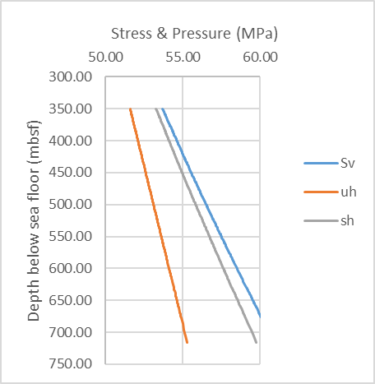
- Two common expressions used to describe the compression behavior of mudrocks are the ‘geotechnical’ approach (Eq. 1) and the ‘Hubbert’ Approach (Eq.2):
$e_{1}=e_{o}-C_{c}\log\left(\frac{σ_{1}^{'}}{σ_{o}^{'}}\right)$ Eq. 1
$n={n_{0}e}^{-βσ_{v}^{'}}$ Eq. 2
$σ_{v}^{'}=σ_{v}-u$ Eq. 3
$e=\frac{n}{1-n}$ Eq. 4

$e_{o}$ is a reference void ratio commonly taken at a vertical effective stress, $σ_{o}'$, of unity, and Cc is a compression coefficient. In Eq. 2, n is porosity, n_{o} is a reference porosity at an effective stress of zero and $β$ is a compressibility parameter. Equation 3 is the effective stress equation. In locations where the pore pressure is hydrostatic, u is the hydrostatic pressure $u_{h}$.

- Plot void ratio (e) vs. the log of hydrostatic effective stress $(σ_{vh}^{'}=σ_{v}-u_{h})$. Use regression to determine the parameters $e_{0}, and C_{c}$. After you have derived $e_{0}, and C_{c}$, then please substitute them in Eq. 1 and plot this line.
- Plot porosity (n) vs. hydrostatic effective stress ($σ_{vh}^{'})$ and use regression to determine the parameters $n_{o}, β$. After you have derived $n_{o} \& β$, then please substitute them in Eq. 2 and plot this line.
- Please determine the value of $m_{v}$ at 3.0 and 4.0 MPa. Remember that the coefficient of compressibility is the slope of the void ratio vs. effective stress plot divided by 1+void ratio at the location the slope is taken:

$m_{v}=\left(\frac{-1}{1+e}\right)\frac{de}{dσ^{'}}$ Eq. 5
- Plot porosity vs. depth for the 1173 well adjacent to your pressure vs. depth plot (#1 above).

Step 1 is to determine the compression parameters for the 1173 well using the geotechnical approach. In the figure below, I have performed a linear regression of the following equation:
$$e=e_{o}+C_{c}log⁡(σ_{v}^{'})$$
$$we find:e_{0}=1.50, and C_{c}=1.31$$
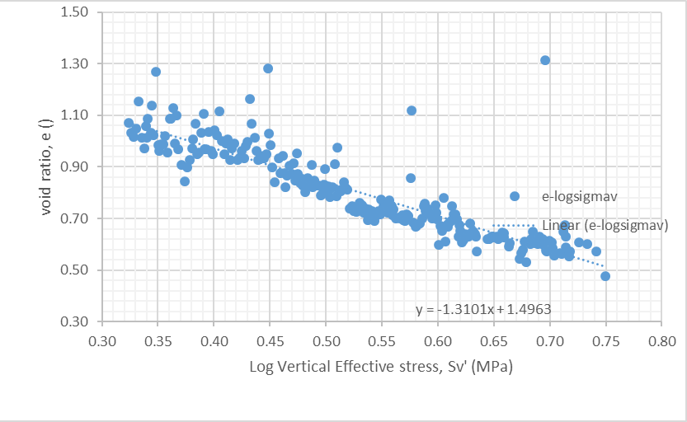
I have repeated the exercise here for the Hubbert approach:
$$n=n_{o}e^{-βσ_{v}'}$$

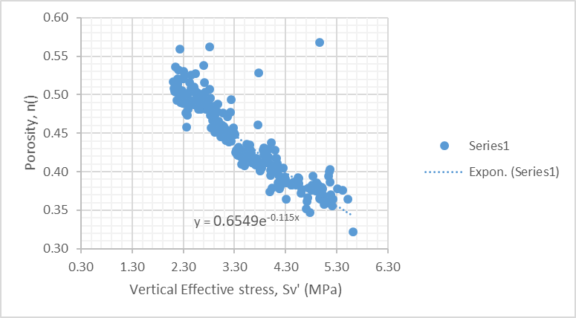
I find:
$$n_{o}=0.65$$
$$β=-0.115 MPa^{-1}$$

I leave it to you to plot the porosity vs. depth
m_{v} is defined in Eq. 5:

A plot of void ratio vs effective stress is:

I fit a power-law function to the plot of void ratio vs. effective stress. In the attached page, I calculate m_{v} for the stress at 3.0 and 4.0 MPa. I find mv = 0.11 MPa⁻¹ at 3 MPa and 0.07 MPa⁻¹ at 4 MPa. This demonstrates that m_{v} decreases with increasing stress. This implies the rock gets stiffer as it compacts. This makes sense because one can envision more particle contacts with decreasing porosity.
