HW-3a: Compression Behavior in the Lower Shikoku of the Nankai Fold and Thrust Belt
We will study the compression behavior in the Nankai Trough at IODP Site 1173. Figures 1 and 2 provide a general overview of this location.

- See the spreadsheet associated with this homework. For Site 1173, please calculate the overburden from the seafloor downwards. Note that the data start at 350 meters below seafloor. I have provided the total vertical stress $(σ_{v})$ and the hydrostatic pressure at 350 mbsf (meters below seafloor) in the spread sheet. The water depth is 4795.7 meters. Assume that the pore pressure is hydrostatic.
  - Construct a pressure-depth plot from the seafloor to total depth.
    - Include hydrostatic pressure. Assume a water density of 1023 kg/m3.
    - Include the overburden stress. Calculate the overburden stress from 350 meters downward by integrating the bulk density, which you infer from the measured porosity (given in the spread sheet). Assume a solid sediment density of 2750 kg/m3 (this is slightly denser than quartz, but that is because clays are denser than quartz).
    - Include the least principal stress assuming uniaxial strain and that K₀ is 0.8 and that the pore pressure is hydrostatic. Remember that $K_{0}=\frac{σ_{3}^{'}}{σ_{1}^{'}}$.

- Two common expressions used to describe the compression behavior of mudrocks are the ‘geotechnical’ approach (Eq. 1) and the ‘Hubbert’ Approach (Eq.2):
$e_{1}=e_{o}-C_{c}\log\left(\frac{σ_{1}^{'}}{σ_{o}^{'}}\right)$ Eq. 1
$n={n_{0}e}^{-βσ_{v}^{'}}$ Eq. 2
$σ_{v}^{'}=σ_{v}-u$ Eq. 3
$e=\frac{n}{1-n}$ Eq. 4

$e_{o}$ is a reference void ratio commonly taken at a vertical effective stress, $σ_{o}'$, of unity, and Cc is a compression coefficient. In Eq. 2, n is porosity, n_{o} is a reference porosity at an effective stress of zero and $β$ is a compressibility parameter. Equation 3 is the effective stress equation. In locations where the pore pressure is hydrostatic, u is the hydrostatic pressure $u_{h}$.

- Plot void ratio (e) vs. the log of hydrostatic effective stress $(σ_{vh}^{'}=σ_{v}-u_{h})$. Use regression to determine the parameters $e_{0}, and C_{c}$. After you have derived $e_{0}, and C_{c}$, then please substitute them in Eq. 1 and plot this line.
- Plot porosity (n) vs. hydrostatic effective stress ($σ_{vh}^{'})$ and use regression to determine the parameters $n_{o}, β$. After you have derived $n_{o} \& β$, then please substitute them in Eq. 2 and plot this line.
- Please determine the value of $m_{v}$ at 3.0 and 4.0 MPa. Remember that the coefficient of compressibility is the slope of the void ratio vs. effective stress plot divided by 1+void ratio at the location the slope is taken:

$m_{v}=\left(\frac{-1}{1+e}\right)\frac{de}{dσ^{'}}$ Eq. 5
- Plot porosity vs. depth for the 1173 well adjacent to your pressure vs. depth plot (#1 above).

- Describe which approach (geotechnical or Hubbert) you think is most appropriate (and why) for these rocks.

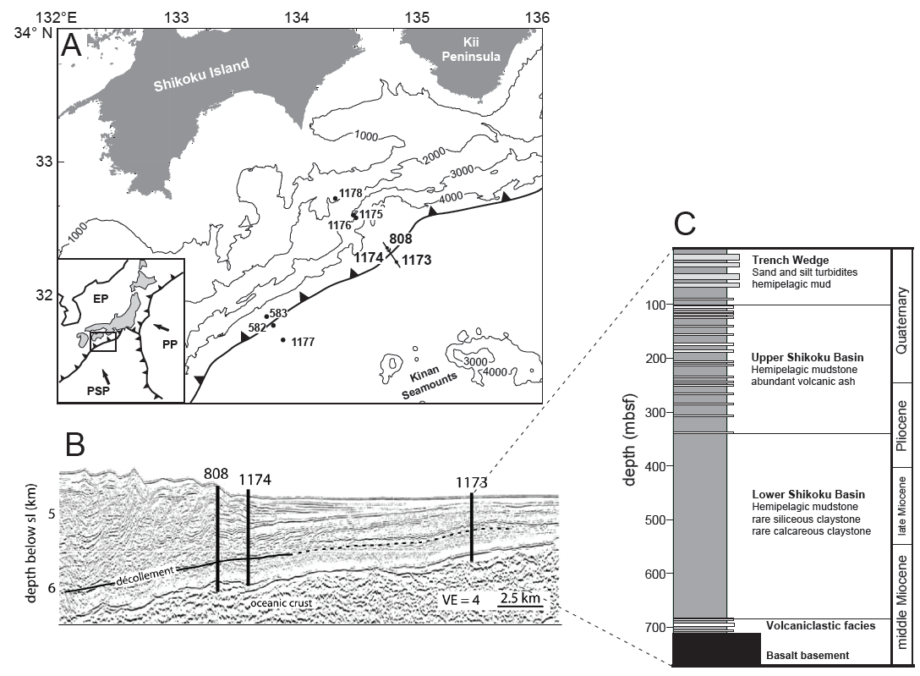
Figure 1. (a) Map of the Nankai Trough, with Deep Sea Drilling Project and Ocean Drilling Program drill sites noted; inset shows tectonic setting. PP = Pacific Plate; PSP = Philippine Sea Plate; EP= Eurasian Plate. (b) Seismic depth section (location shown in part a) showing the locations of Sites 1173, 1174, and 808. VE = vertical exaggeration. (c) Stratigraphic section from continuous sampling and core descriptions at Site 1173. Reprinted from Flemings and Saffer (2018) with permission by John Wiley and Sons. Figure 6.13 of Flemings (2021).

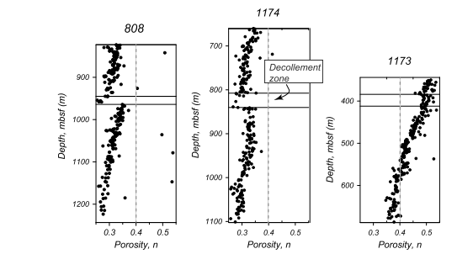
Figure 2. Porosity vs. depth at IODP Site 808, 1174, and 1173. Figure 2. Porosity versus depth at Ocean Drilling Program (ODP) Sites 808, 1174, and 1173 within the Lower Shikoku Basin (LSB) facies. At ODP Site 808, the LSB facies extends from 823 to 1,243 m below seafloor (mbsf) and the décollement zone is between 945 and 964 mbsf (Taira et al., 1991). At ODP Site 1174, the LSB facies extends from 661 to 1,102 mbsf and the décollement zone lies between 807.6 and 840.2 mbsf (Moore et al., 2001). At Site 1173, the LSB facies extends from 343.8 to 688.0 mbsf. The stratigraphic equivalent of the décollement (the protodécollement), determined by correlating magnetic susceptibility depth data from cores, is from 384 to 412 mbsf (Mikada et al., 2002). The porosity measurements are derived from moisture and density measurements on recovered core samples. Core expansion was estimated by comparing the core porosities to the logging-while-drilling porosities. To correct for core expansion, 0.03 porosity units were subtracted from the measured values at Site 1173 and 0.04 porosity units were subtracted from the measured values at both Site 1174 and Site 808. mbsf = meters below seafloor. From Flemings and Saffer (2018).

