HW-2c: Characterizing Reservoir Pressure in a fish tank

# Introduction:

In this problem set we characterize the pressure in a simple fish tank.

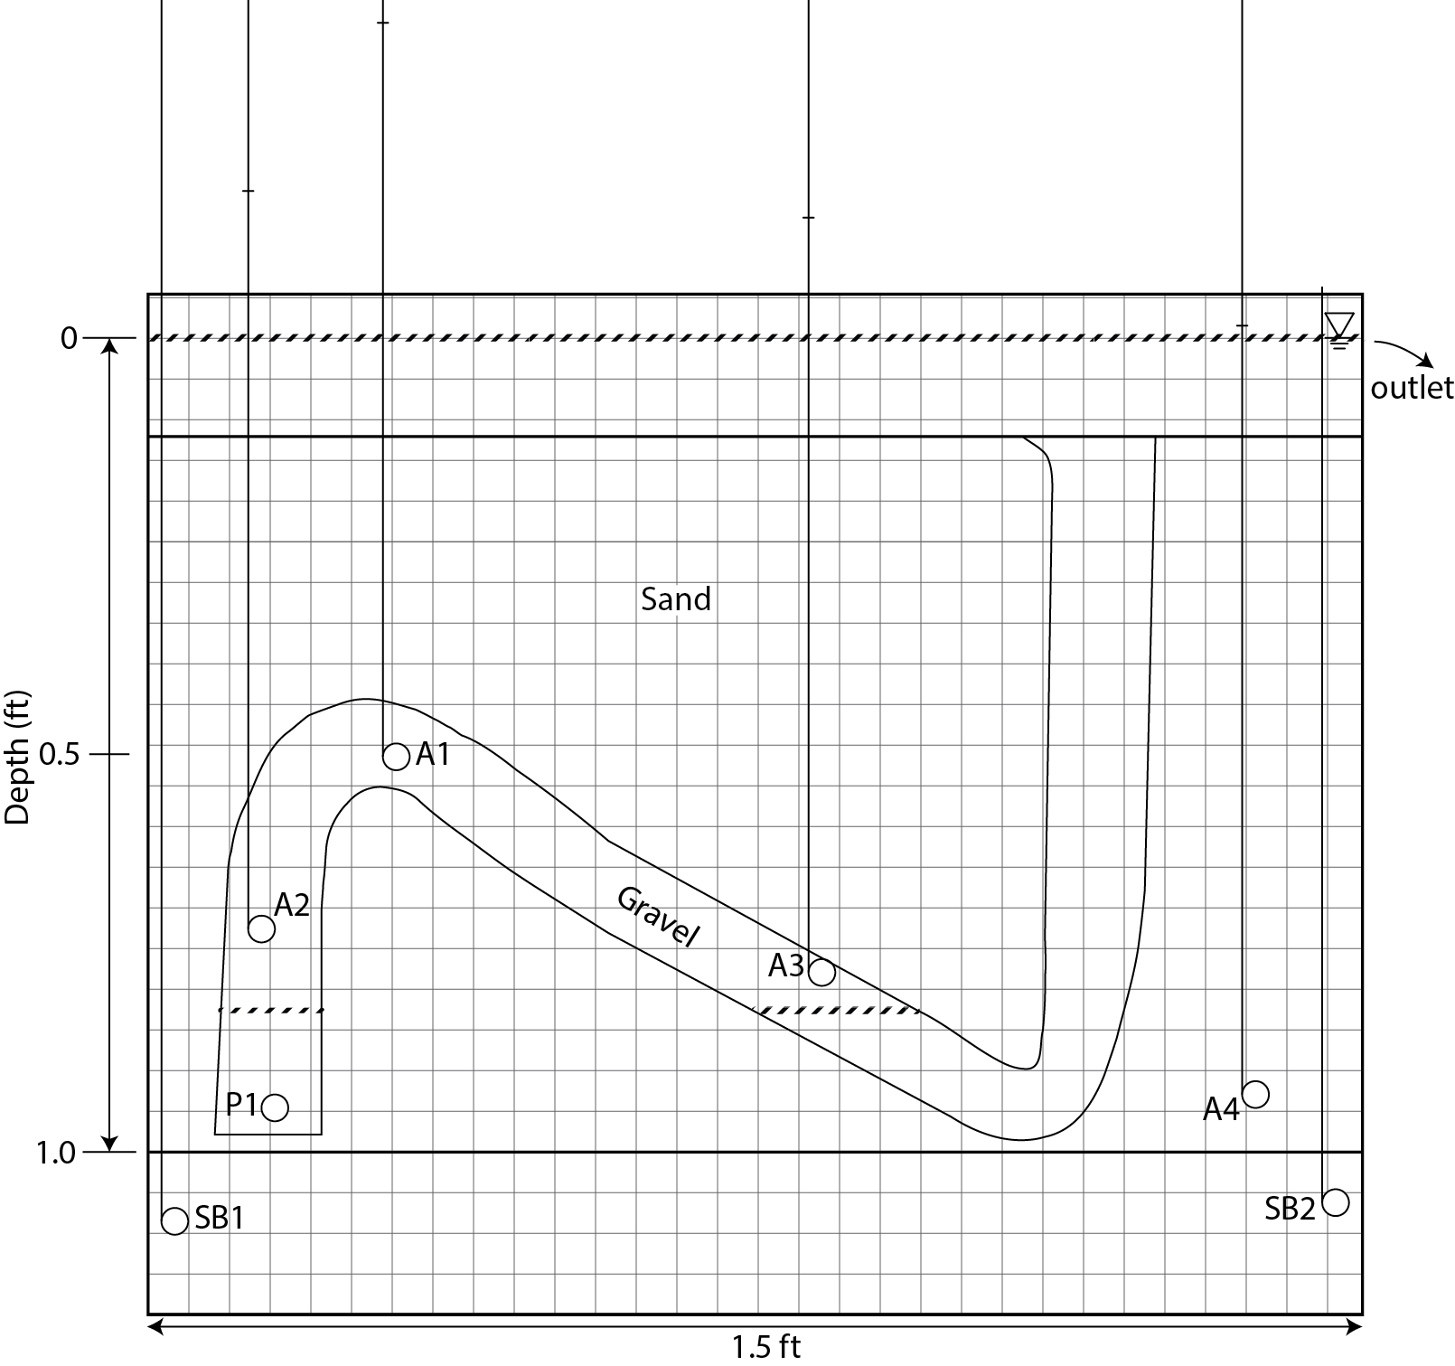

***Figure 1: The Fish tank Basin. Each square represents a distance 0.1 in. Please color in red the zone filled with air and in blue the zone filled with water. Note the position of the water surface in the manometers (vertical tubes).***

# Observations:

|  |  |  |  |  |  |
| --- | --- | --- | --- | --- | --- |
| **Manometer Levels** | **Depth (ft)** | **Ht. (ft)** | **ue (psi)** | **u (psi)** | **EMW (ppg)** |
| A1 | 0.49 | 0.39 | 0.17 | 0.38 | 14.88 |
| A2 | 0.71 | 0.18 | 0.08 | 0.38 | 10.46 |
| A3 | 0.75 | 0.15 | 0.06 | 0.39 | 9.96 |
| A4 | 0.92 | 0.02 | 0.01 | 0.41 | 8.51 |
| SB1 | 1.10 | 0.00 | 0.00 | 0.48 | 8.33 |

***Table 1: Head levels and depths of manometers in experiment.***

|  |  |
| --- | --- |
| **INPUT PARAMETERS** |  |
| overburden gradient (psi/ft) | 0.86 |
| hydrostatic gradient (psi/ft) | 0.433 |
| gas gradient (psi/ft) | 0.00052 |
| Sea Floor (ft) | 0.05 |
| Top of Structure (ft) | 0.44 |
| G/W Contact (ft) | 0.83 |
| Base of Structure (ft) | 0.99 |
| Base of Model (ft) | 1.00 |

***Table 2: Input parameters and depth of fluid contacts.***



***Table 3: Equivalent mudweight for gas phase assuming that the gas pressure equals the water pressure at the fluid contact and that the gas density is zero.***

1. On the graph paper provided (Figure 2), the hydrostatic pressure (uh) and the overburden stress (σv) have been drawn based on the gradients provided in Table 2. Draw horizontal lines at the structural crest and gas-water contact. Plot the values of the pressure at A1, A2, A3, A4, and SB1.

1. Assume the density of the gas phase is zero. Plot gas phase pressure in the system by projecting a vertical line upwards from the gas-water contact to the crest of the structure. Compare this model to the observed pressure data.
2. Express the resultant pressure field in an EMW plot (Fig. 3). To make your life easier, I have also calculated the gas pressure in mudweights assuming it extends from hydrostatic pressure at the base to the crest (Table 3).

1. What is the capillary pressure at the crest of the structure? What mud weight would you need to drill into the crest?

1. Why do you think the measured gas pressures are greater than those predicted by Table 3. Think hard about this and relate it to our discussion of capillary pressures.