HW-2b: Characterizing Reservoir Pressure
(u_{d}>0)

Effect of Displacement Pressure (ud) on FWL vs OWC

Introduction:

The Bullwinkle oil field is located on the western flank of a circular salt-withdrawal mini-basin on the slope of the Gulf of Mexico, approximately 150 miles to the southwest of New Orleans, Louisiana (Figure 1). A depth to top of structure map is provided for the J3 producing interval (Figure 2).

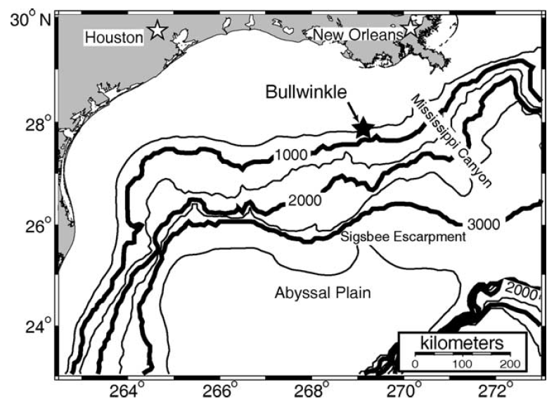
Figure 1: The Bullwinkle Basin (Green Canyon 65 and 109) is on the upper continental slope in approximately 1300 ft. water depth (400m) ~ 150 miles southwest of New Orleans.
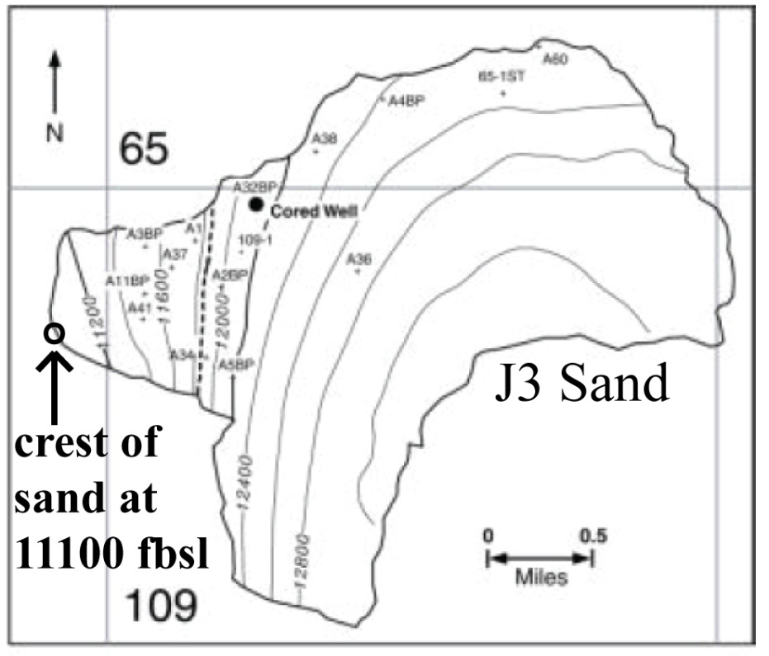
Figure 2: Map of the depth of the J3 sand in feet beneath the sea surface. The polygon marks the boundary of the J3 sand. The structural crest of the sand is along the western margin at ~11,100 feet below sea level and the oil-water contact (OWC) is at 11,850 ft. These results are based on Flemings et al. (2001).

Task:
- On the graph paper provided (Figure 4), plot the following pressure profiles from sea level through the J3 Sand: 1) Hydrostatic pressure, u_{h;} 2) Overburden stress, σ_{v}. Draw horizontal lines at the structural crest and the oil-water contact.

- Assume that the reservoir rock oil-water capillary pressure behavior is described by the “high displacement” case (Figure 3). Determine the displacement pressure (u_{d}) from Figure 3 and label it on Figure 3.

- Plot the water phase (u_{w}) and oil phase (u_{o}) pressures in the J3 sand (Fig. 5).

- Based on this assumption, where is the free-water level (FWL) in relation to the OWC? Record your FWL depth in Table 1.

- What are the oil, water, and capillary pressures at the crest of the J3 sands?

- Calculate the aquifer excess pressure. Please enter your answers in Table 1. Overlay the interpretation from HW 2a. Explain why these results are different. Why is the estimated aquifer ovepressure in this example different from the case with no reservoir displacement pressure (HW 2a)?

Data:
Datums (ft Below Sea Level (BSL)) |  |  | Direct J3 Pore Pressure Measurement
Sea Floor | 1,350 |  | 8,100 psia at 11,500 ft BSL
Crest of J3 Sand | 11,100
Oil Water Contact (OWC) | 11,850

Pressure Gradients (psi/ft)
Overburden |  | 0.93
Hydrostatic |  | 0.465
Oil |  | 0.286
Table 1:
High Displacement Pressure Scenario
Capillary Pressure (u_{ow})at OWC (psia)
FWL Depth (ft BSL)
 | Oil |  |  | Water | Capillary (u_{cow})
Pressures at Top of J3 Sand (psia)
Aquifer Excess Pressure (psia)

Figure 3: Capillary pressure curve data (oil-water) for the J3 reservoir. The “low displacement pressure” curve is the real J3 data. The Leverett J function was used to generate the “high displacement pressure” curve by decreasing the permeability from by a factor of 1000. The following parameter values were used to generate the Leverett J function: contact angle = 23degrees, interfacial tension = 20 dyne/cm, porosity = 32.5%, base permeability = 100md.

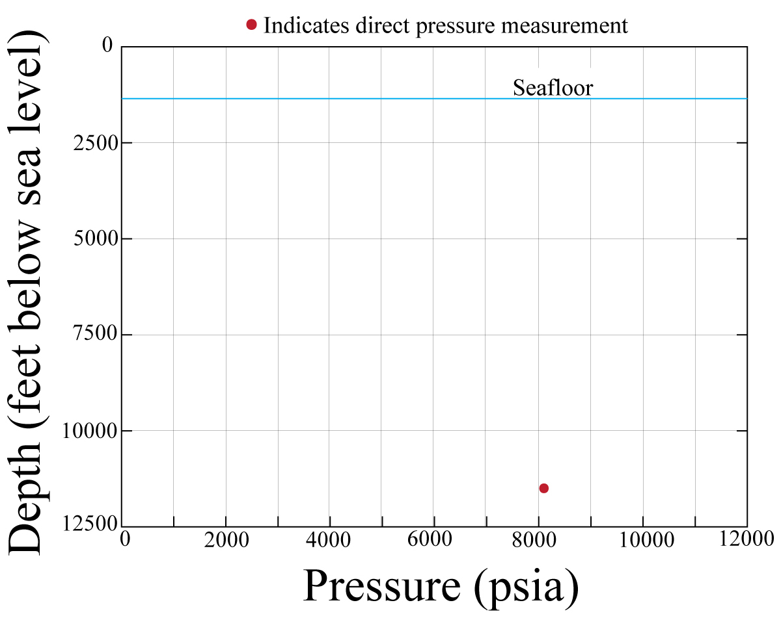
Figure 4: Graph paper for question 1. Plot hydrostatic stress, overburden stress, and oil pressure.
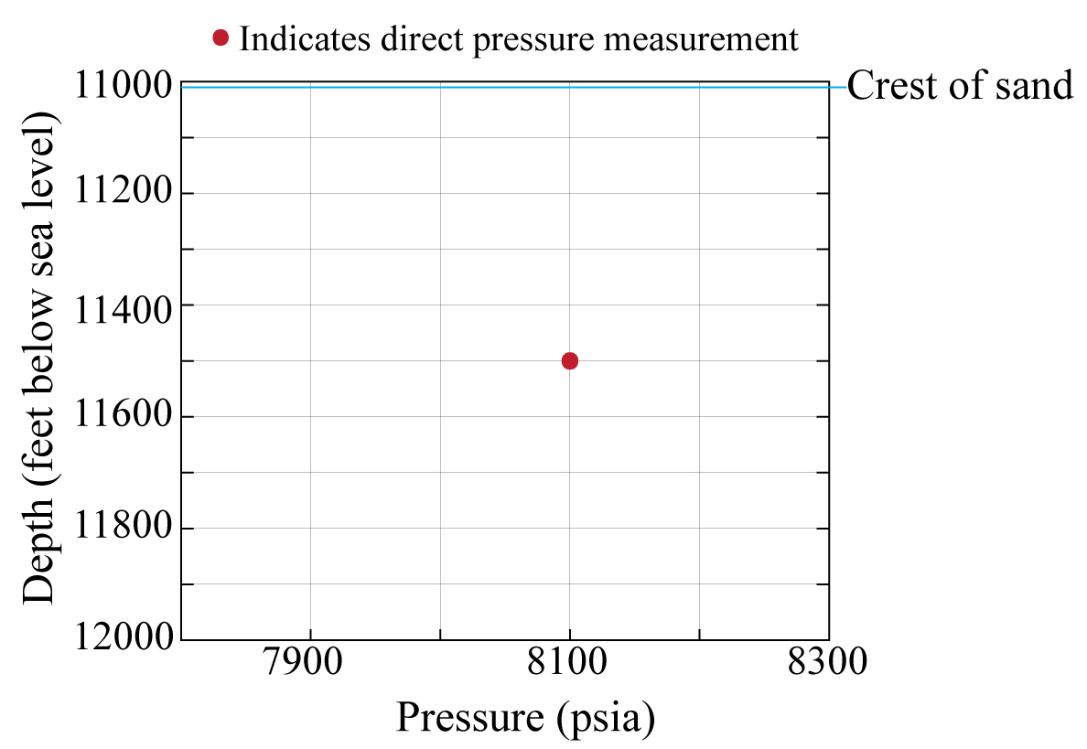
Figure 5: Graph paper for question 2. Plot hydrostatic stress, overburden stress, and oil pressure. Also indicate the OWC, the FWL and the water pressure for the zero displacement pressure case.

