HW-2: Characterizing Reservoir Pressure
(u_{d}=0)
Zero Displacement Pressure in reservoir

Introduction:

The Bullwinkle oil field is located on the western flank of a circular salt-withdrawal mini-basin on the slope of the Gulf of Mexico, approximately 150 miles to the southwest of New Orleans, Louisiana (Figure 1). A depth to top of structure map is provided for the J3 producing interval (Figure 2).

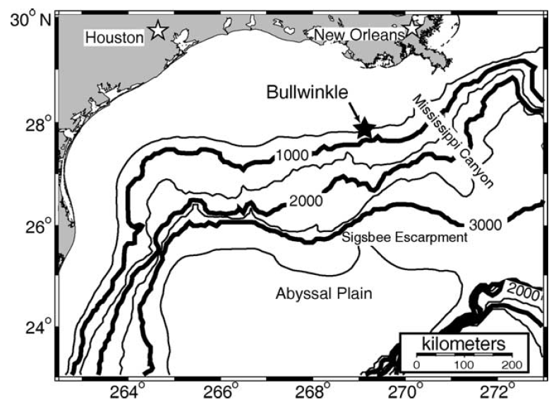
Figure 1: The Bullwinkle Basin (Green Canyon 65 and 109) is on the upper continental slope in approximately 1300 ft. water depth (400m) approximately 150 miles southwest of New Orleans. These results are based on Flemings et al. (2001).

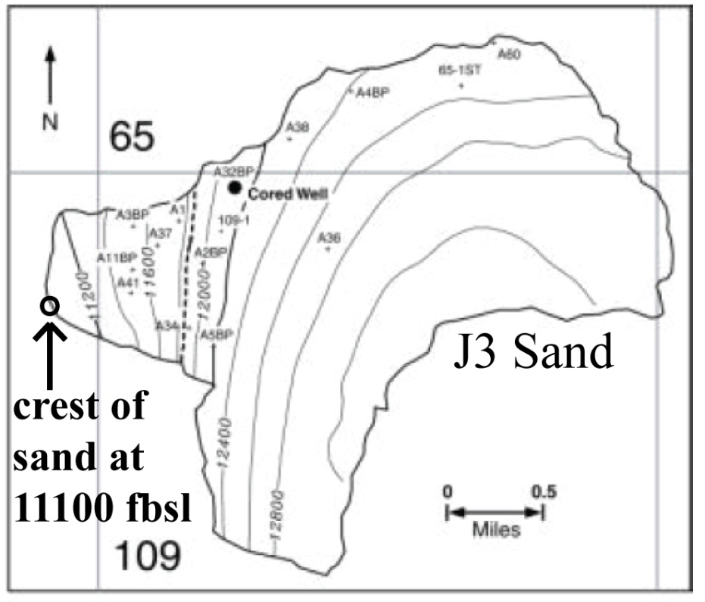
Figure 2: Map of the depth of the J3 sand in feet beneath the sea surface. The polygon marks the boundary of the J3 sand. The structural crest of the sand is along the western margin at ~11,100 feet below sea level and the oil-water contact (OWC) is at 11,850 ft.

Task:

- On the graph paper provided (Figure 3), plot the following pressure profiles from sea level through the J3 Sand: 1) Hydrostatic pressure, u_{h;} 2) Overburden stress, σ_{v}. Draw horizontal lines at the structural crest and oil-water contact.

- On Figure 4, plot the water phase pressure (u_{w}) and the oil phase pressure (u_{o}) in the J3 sand. The reservoir rock is of very high quality (good permeability and well-sorted). Thus, please assume that the displacement pressure (u_{d}) of the reservoir is zero. Based on this assumption, where is the free-water level (FWL) in relation to the OWC? Record your FWL depth in Table 1.

- Using your plot (Figure 4), what are the oil, water, and capillary pressures at the crest of the J3 sands? Estimate the aquifer excess pressure. Please enter your answers in Table 1.

Data:

Datums (ft Below Sea Level (BSL)) |  |  | Direct J3 Pore Pressure Measurement
Sea Floor | 1,350 |  | 8,100 psia at 11,500 ft BSL
Crest of J3 Sand | 11,100
Oil Water Contact (OWC) | 11,850

Pressure Gradients (psi/ft)
Overburden | 0.93
water | 0.465
Oil | 0.286

Table 1. Record your answers here.

Zero Displacement Pressure Scenario
Capillary Pressure at OWC (psia)
FWL Depth (ft BSL)
 | Oil | Water | Capillary (u_{cow})
Pressures at Top of J3 Sand (psia)
Aquifer Excess Pressure (psia)

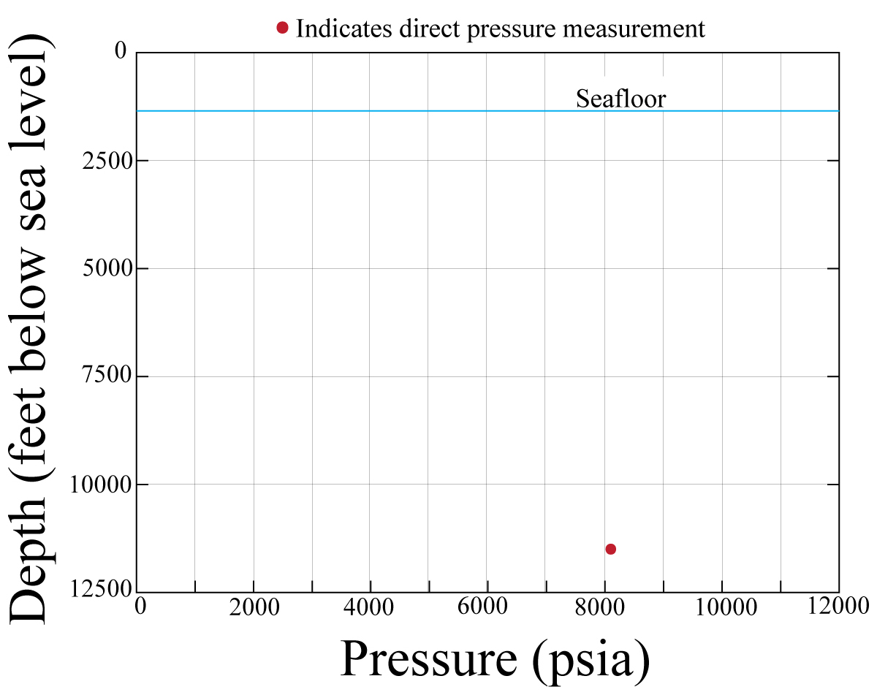
Figure 3: Graph paper for question 1. Plot hydrostatic stress, overburden stress, and oil pressure.

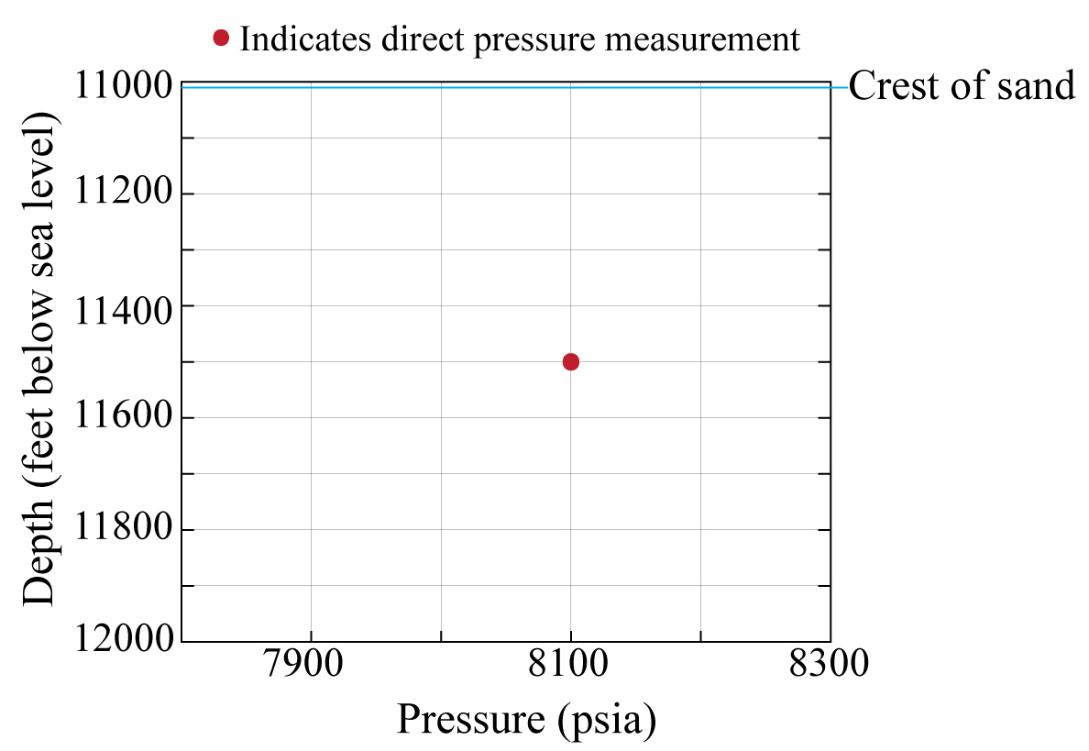
Figure 4: Graph paper for question 2. Plot the J3 oil and water pressure profiles. Also, carefully indicate the OWC and FWL.

