HW-15a: Flow Focusing in a Fish Tank

Overview
In this homework you will plot the pressure fields associated with Figure 10.1 in the text. The example illustrates the pressure field associated with flow focusing. It drives home that the pressure gradient within the permeable ‘sand’ follows the hydrostatic gradient whereas the pressure gradient in the bounding ‘mudrock’ is greater. It also illustrates how the pressure is lower at the base of the sand and elevated at the crest of the sand.

Exercise 1: Predict Flow Direction
In Figure 1, the values of excess pressure are shown. Please contour the excess pressure within the ‘mudrock.’ I recommend a contour interval of 0.05 PSI. The upper surface has an excess pressure equal to zero. Draw arrows in that you think records the flow direction through the ‘mudrock.’

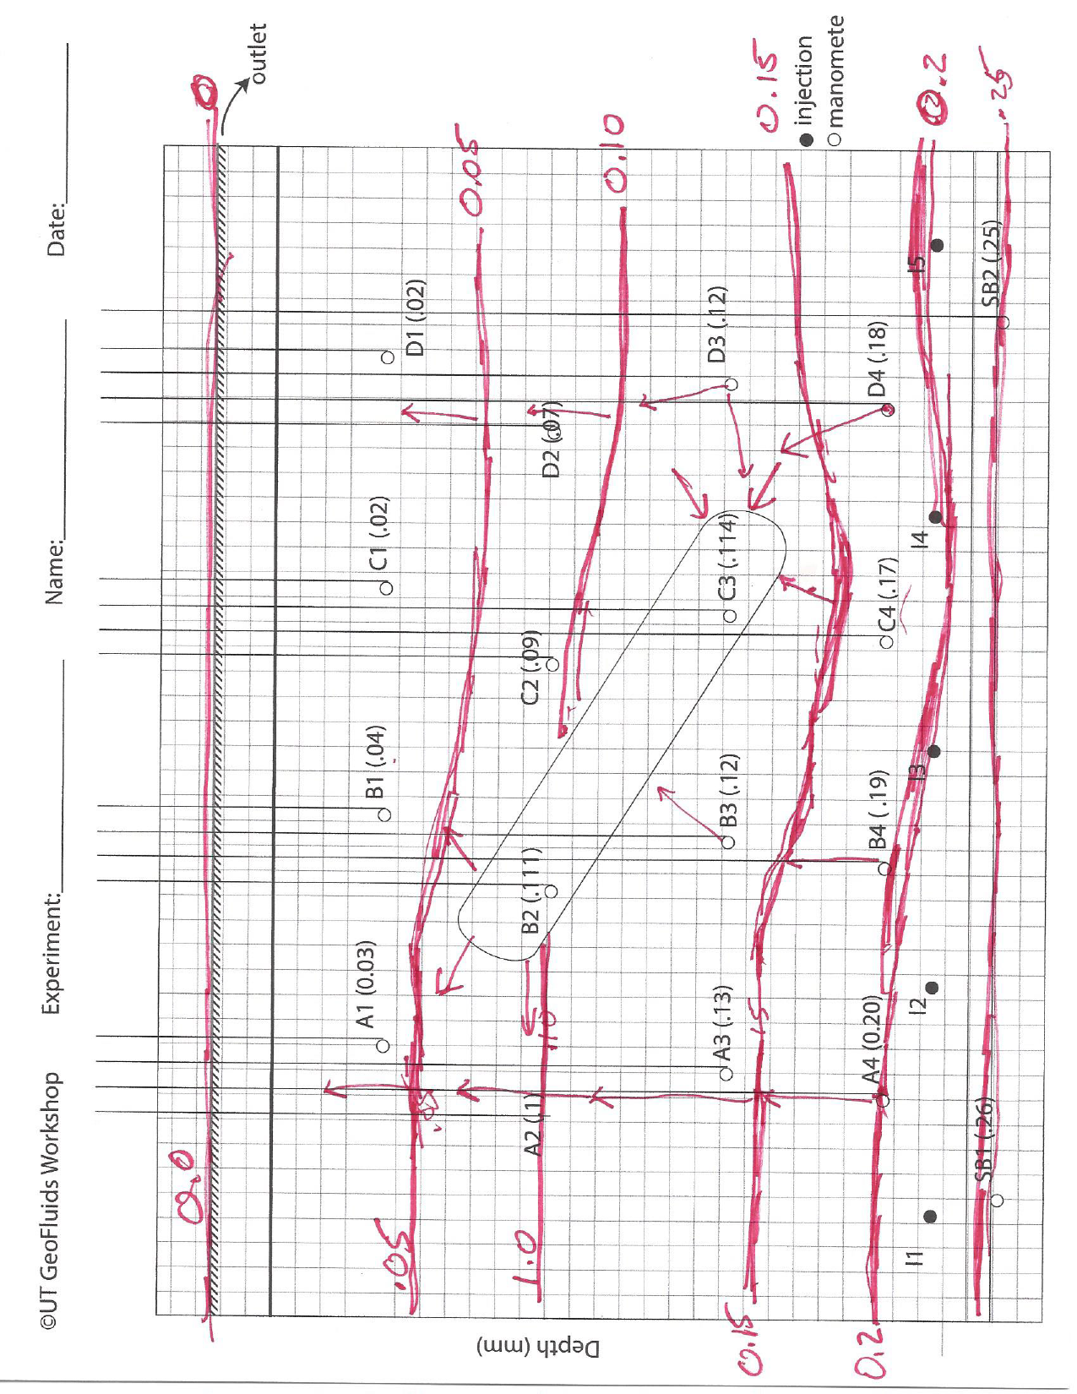
Figure 1: a) A tilting sandstone reservoir is surrounded by low permeable mudstone. Overpressure (ue, PSI) is shown in parentheses.

Exercise 2: Construct Pressure-Depth Plot

On the following plots, please plot the mudstone pressure and the reservoir pressure.
Mudstone Pressure
Manometer Levels | Depth (ft) | u (psi) | ue (psi) | EMW (PPG)
seafloor | 0.10 | 0.05 | 0.00 | 8.3
A1 | 0.24 | 0.14 | 0.03 | 11.1
A2 | 0.46 | 0.30 | 0.10 | 12.4
A3 | 0.67 | 0.43 | 0.13 | 12.2
A4 | 0.89 | 0.58 | 0.20 | 12.6
SB1 | 1.09 | 0.73 | 0.26 | 12.9
Table 1:
Sandstone Pressure
Manometer Levels | Depth (ft) | u (psi) | ue (psi) | EMW (PPG)
B2 | 0.47 | 0.32 | 0.11 | 12.8
C3 | 0.69 | 0.41 | 0.11 | 11.5
Table 2:

