Ochoa, Chelsea M

JSG Undergraduate externship program Host Guide 2024

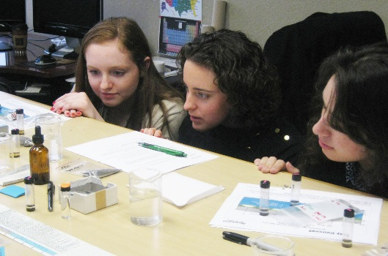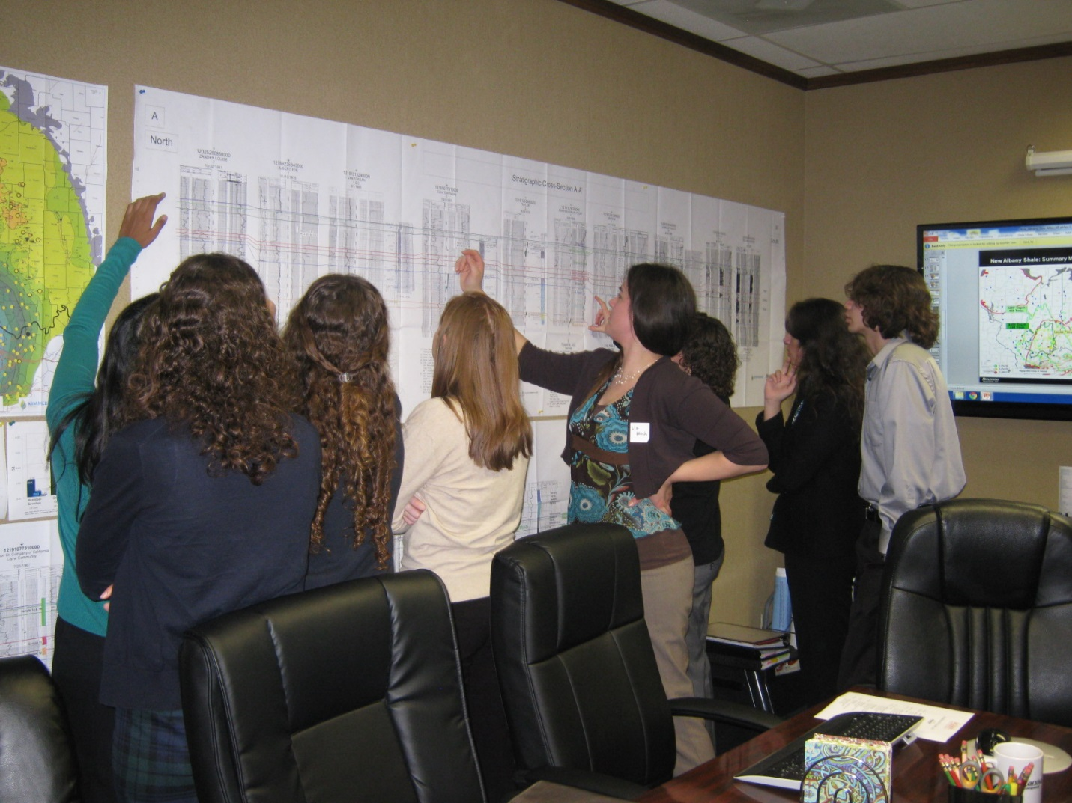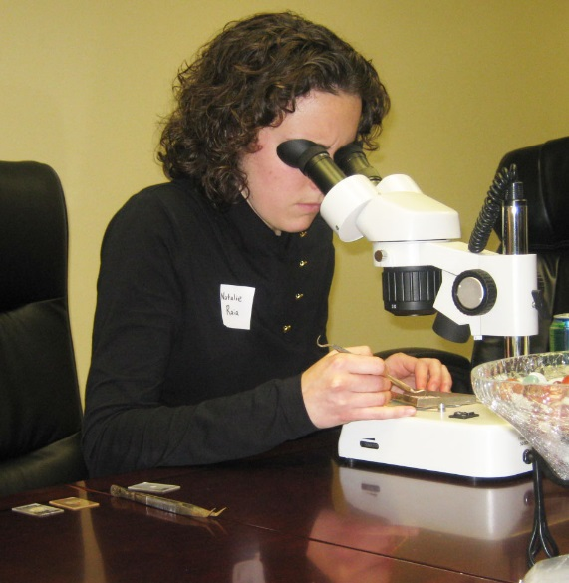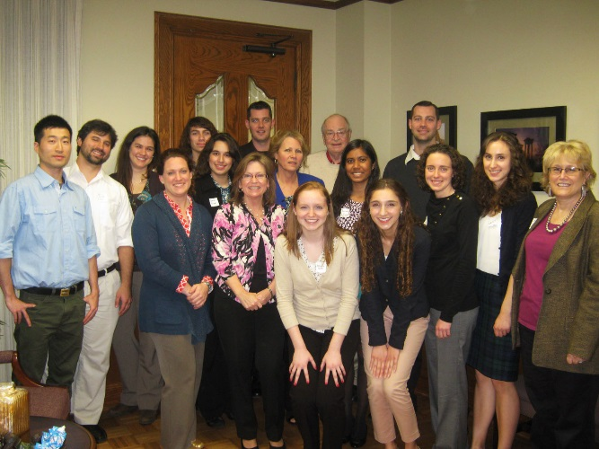

## Table of Contents

Introduction to the Externship 2

Host, Student & Career Center Responsibilities 3

Planning the Externship & Sample Agendas 4

Student Feedback & Tips 6

Contact Information 7

**Introduction to the Externship**

**Program Overview**

The Jackson School of Geosciences Undergraduate Externship Program offers an opportunity for undergraduate students to engage in career exploration. Jackson School of Geosciences (JSG) alumni, friends and interested companies host student externs for a day of shadowing and networking during an academic break. Externships are hosted in all major cities in Texas.

**Student Demographics**

While this program is open to all JSG undergraduate students, it is primarily marketed to freshmen and sophomores. The JSG Career Services will work with you to identify the majors and level of student that would benefit most from your externship. You will receive a list of registered students at least one week prior to the externship with their major, year in school and contact information.

**Program Benefits**

As a host, you have the opportunity to:

* Make a meaningful contribution to students’ career development.
* Share your career path and advice for students on gaining the necessary skills and experiences to be successful in the future.
* Build relationships with current students and stay connected to the Jackson School.
* Increase awareness of your company within the Jackson School community.

Students participate in order to:

* Explore career options and evaluate their level of interest in various industries,   
  work environments and career paths.
* Experience the real life application of their coursework.
* Begin building a professional network.

**Note:** This is not a recruitment program, and there is no expectation of hiring student externs now or in the future. The externship is marketed to students as an experiential learning opportunity for the purpose of career exploration.

**Responsibilities**

**Host Responsibilities**

* Commit to a half or full day externship and provide a rough description of what students can expect to experience and learn.
* Review this host guide and contact career services with any questions.
* Provide day-of logistics to student participants at least 2 weeks in advance of the externship, including office location, parking instructions, relevant check-in/security procedures, and start/end times. Please also provide details on whether you will offer lunch or if students should make other arrangements. Providing lunch is not a requirement.
* Plan a half or full day schedule for the student extern(s). There are sample agendas at the end of this guide, and the JSG Career Center can provide additional guidance if necessary.
* Provide feedback on your experience via phone or email. Career Services reach out within a week of the externship for this purpose.

**Student Responsibilities**

* Arrange transportation to/from the externship.
* Arrive on-time; be curious and engaged throughout the entirety of the externship.
* Demonstrate professionalism through appropriate dress and communication style.
* Complete an evaluation after the externship to provide feedback for improvement.

**Career Services Responsibilities**

* Market externship opportunities to students and oversee registration.
* Communicate professionalism (tips on how to dress, arriving on time, needing to cancel) to students in advance of the externship.
* Provide host with student information at least one week prior to the externship.

**Planning the Externship**

**Suggested Activities**

Students most commonly report that they want to see “a day in the life” of a geoscientist. It is highly encouraged that you incorporate some individual job shadowing into the externship to help students understand typical work activities.

The following is a list of suggested activities. This should be viewed as a starting point; you are welcome to plan activities and experiences that are not on this list.

* Tour of facilities
* Overview of company, staff roles and current projects
* In-depth look at a project life cycle
* Presentation on how to be a successful job candidate in the future
* Individual or small group meetings for informational interviews
* Demonstration of computer software or frequently used tools
* Discussion on current trends in your industry
* One-on-one job shadowing

**Sample Agenda: Half-Day**

9:00-9:30 Welcome and introductions

9:30-10:00 Company overview and workplace tour

* What is your area of specialty?
* Where does your company fit into the industry?
* What type of geoscientists work at your company?

10:00-11:30 Informational interviews with staff (rotate every 30-45 minutes)

* Describe your role and typical work activities
* Demonstrate software or computer programs that are integral to your work
* Allow time for Q&A with student

11:30-12:00 Discussion with staff about preparing for the future

* Share your career path and advice on getting started in your field
* Go over interview skills, resume tips, important classes and skills, etc.

12:00-1:00 Lunch (Optional)

* Have lunch at your office or take the student out to lunch for further conversation. While you are welcome to buy the student lunch, this is not expected or required!

**Sample Agenda: Full Day**

9:00-9:30 Welcome and introductions

9:30-10:00 Company overview

* What is your area of specialty?
* Where does your company fit into the industry?
* What type of geoscientists work at your company?

10:00-10:15 Break

10:15-11:00 Project overview or other interactive activity

* Walk students through a current project. Who is involved, where is it,   
  what is the scope, and what steps are involved?
* Use visuals: maps, samples, computer programs, etc.

11:00-11:30 Hiring from an employer’s perspective

* Share resume and interview tips
* Suggest helpful classes, organizations, etc.

11:30-1:00 Lunch

1:00-3:00 Informational interviews/shadowing with staff (rotate every 30-45 minutes)

* Describe your role and typical work activities
* Demonstrate software or computer programs that are integral to your work
* Allow time for Q&A with student

3:00-3:30 Wrap-Up, Q&A

**Student Feedback & Tips**

Past externship participants have shared what activities they found most helpful and what makes a successful externship.

* *“I greatly valued our discussion concerning the classes we should take to become more prepared for a career in petroleum geology and the qualifications that employers look for when hiring petroleum geologists.”*
* *“I liked when we got into small groups of two students with an employee on the computer to interact and see how the database is used to research past wells and make maps and analyses to find new prospects. It was a good setting to ask questions and do something employees actually do.”*
* “*I benefited from hearing what the company looks for in students. It’s good to know that the courses you take, extracurricular activities, and involvement in the university can be just as important as the grades you make.*”
* “*I observed geologists teaming up with engineers to reach a goal, and learned that even during a downturn in oil prices, exploration geologists continue their work as usual searching for potential spots to drill in the future. It was comforting to converse with geologists who have experienced these downturns and who are confident that prices will bounce back in the future.”*
* *“It’s good if the host is enthusiastic and the day is interactive – not good if sitting in one room all day looking at PowerPoint. The company I visited did a very good job having us moving about and doing a lot of things to get a whole view of what goes on in the office.”*
* “*This externship was definitely worth my time as it showed me generally what I should expect if I decide to work in the oil industry. I wish they talked more about what someone would do on a daily basis in their job.*”
* *“I really liked being introduced to the office culture. It could have been a very formal, stiff experience, but I felt like they were really candid with us, which I appreciated. What’s the point of attending an externship if you don’t come away with a true impression of the place?”*
* *“We were able to split into smaller groups and see hands-on what different employees do on a daily basis. I think it would be beneficial for future externs if companies could have similar activities where we actually get to see some of the different things they do in a day. This may help students determine if they could see themselves doing those activities as a career.* ”

**Contact Information**

Thank you for giving your time and energy to host an externship. Students benefit greatly from this opportunity and we couldn’t do it without you! If you have any questions whatsoever, please contact:

Emma Hardin  
[emma.hardin@jsg.utexas.edu](mailto:emma.hardin@jsg.utexas.edu)

Jennifer Jordan

[jjordan@jsg.utexas.edu](mailto:jjordan@jsg.utexas.edu)